**PHARMACY MANAGEMENT SYSTEM**

* **A PROJECT REPORT**

**Submitted in partial fulfillment of the Requirements for the Degree of**

**MASTER OF COMPUTER APPLICATION**

**by**

**SHANTANU TYAGI**

**(Univ. Roll No.: 1900290140031)**

**Under the Supervision**

**Of**

**Mrs. Vidushi**

**Assistant Professor**



**Submitted to**

**DEPARTMENT OF COMPUTER APPLICATIONS**

**KIET Group of Institutions, Ghaziabad**

**Uttar Pradesh (201206)**

**DR. A.P.J. ABDUL KALAM TECHNICAL UNIVERSITY, LUCKNOW (JUNE ,2022)**

* **// don’t use underline with heading**
* **DECLARATION**

I hereby declare that the work presented in this report entitled “Pharmacy Management System, was carried out by me. I have not submitted the matter embodied in this report for the award of any other degree or diploma of any other University or Institute.

I have given due credit to the original authors/sources for all the words, ideas, diagrams, graphics, computer programs, experiments, results, that are not my original contribution. I have used quotation marks to identify verbatim sentences and given credit to the original authors/sources.

I affirm that no portion of my work is plagiarized, and the experiments and results reported in the report are not manipulated. In the event of a complaint of plagiarism and the manipulation of the experiments and results, I shall be fully responsible and answerable.

Name: Shantanu Tyagi

Roll.No.:1900290140031

Branch: MCA

(Candidate Signature)

* **TRAINING CERTIFICATE**



***Mrs. Vidushi External Examiner***

(Internal Examiner)

Assistant Professor

Dept. of Computer Applications

KIET Group of Institutions, Ghaziabad

Date:

* **ACKNOWLEDGEMENT**

Success in life is never attained single handedly. My deepest gratitude goes to my thesis supervisor, **Mrs. Vidushi** for her guidance, help and encouragement throughout my project work. Their enlightening ideas, comments, and suggestions.

Words are not enough to express my gratitude to **Dr. Ajay Kumar Shrivastava**, Professor and Head, Department of Computer Applications, for his insightful comments and administrative help at various occasions.

Fortunately, I have many understanding friends, who have helped me a lot in many critical conditions.

Finally, my sincere thanks goes to my family members and all those who have directly and indirectly provided me moral support and other kinds of help. Without their support, completion of this work would not have been possible in time. They keep my life filled with enjoyment and happiness.

Shantanu Tyagi

University Roll no.-1900290140031

**Table of Contents**

* **Page No.**
* **Chapter 1. Introduction**
* Introduction to the System 4
* Problem Definition 4
* Aim 5
* Objective 5
* Goal 6
* Need of System 6
* **Chapter 2. Hardware and Software requirement**
* Introduction 8
* System environment 8
* Software requirement 9
* Hardware requirements 10
* **Chapter 3. System Analysis**
* Purpose 12
* Project Scope 12
* Existing System 13
* Proposed System 14
* System Description 15
* **Chapter 4.Implementation issues**
* PHP 17
* HTML 18
* Cascading style sheet(CSS) 19
* MYSQL 20

**Chapter 5. System Design**

* Introduction 21
* Conceptual Design 22
* ER-Diagram 23
* Logical Design 24
* Physical Design 25
* Data Flow Diagram of **“Pharmacy Management System”** 26
* **Chapter 6.User Screens** 27-45

* **Chapter 7.Coding** 46-100

**Chapter 8. Conclusion**

* Features of “**Pharmacy Management System**” 101
* Benefits Accrued from “**Pharmacy Management System**” 102
* Limitations of “**Pharmacy Management System**” 103

* **Bibliography**

**LIST OF FIGURES**

* Use Case Diagram Admin 20
* Use Case Diagram - Pharmacist 21
* DFD(Data Flow Diagram) DFD Level 1 22
* DFD Level 2 23
* ER Diagram 24

1.6 Sequence Diagram For Administration 25

5.1 Sequence Diagram For User 26

5.2 Tables Relationship(Class Diagram) 29

5.3 Home Page 30

5.4 Admin Login Page 31

5.5 Admin Dashboard Page 32

5.6 Invoice Search Page 33

5.7 Medicine Inventory Page 34

5.8 Add Pharmacy Company Page 35

5.9 Manage Pharmacy Company Page 36

5.10 Add Medicine Page 37

5.11 Manage Medicine Page 38

5.12 Add Pharmacy Detail page 39

5.13 Manage Pharmacist Page 40

5.14 Pharmacist Login Page 41

5.15 Pharmacist Dashboard Page 42

5.16 Inventory Page 43

5.17 Search Medicine Page 44

5.18 Cart Page 45

5.19 Print Invoice Page 46

**CHAPTER # 1**

**Introduction**

*Contents:*

* Introduction
* Problem Definition
* Aim
* Objective
* Goal
* Need of System

**Abstract**

Nowadays, Pharmacy management system is one of the most essential tools that are mostly used in medical store; it is mostly used to manage pharmacy related activities

|  |  |  |  |  |
| --- | --- | --- | --- | --- |
| such as medical inventory, record keeping, sales management as well | | | as managing the drug | |
| Stock and information of the expired medicines. Many pharmacies | | |  | are still |
| operating | manually; | they don’t have adequate software to manage their | | Daily activities. It |
| needs the | pharmacist | assistant to check the expired date of the medicine twice a week, and it | | |
| can take a lot of time | | To find out whether certain medicine are out of stock. | |  |

In this project we tried to develop a computerised and web based Pharmacy management system. Our main intention is to allow this application to be used in most retailing pharmacies, where a small point of customization will be required to each pharmacy in the implementation period. This system is designed to overcome all challenges related to the management of medicine that were used to be handled locally and manually.

Pharmacy management system has its own significance to the retail pharmacy shops. Using this system, it will help us to records all transaction made at the daily sales, recognise all customers, employees, balance stock, etc. It will manage all activities around the shop that increases productivity and maximize profit, it will also minimizing the risk of getting loss because all transactions are recorded to the system.

**Introduction to the System :**

Pharmacy management system is designed to improve the accuracy, enhance safety and efficiency in the pharmaceutical store. It is a computer based system which helps the Pharmacist to improve inventory management, cost, medical safety etc.

Pharmacy management system was developed to ensure the security of information and reliability of Pharmacy records when accessing and providing services to the customers. The information gathered during the data collection was properly analysed and the results provided the basis for the new system. The system was tested and found to be functional and the outputs produced by this system were encouraging. The application will hence reduce the loss of information unlike the existing system and also information will be processed fast.

**Problem Definition:**

* No use of Web Services and Remoting.
* Risk of mismanagement and of data when the project is under development.
* Less Security.
* No proper coordination between different Applications and Users.

**Objective:**

The overall objective of this project is to establish a System for pharmacy shops so as to improve the performance and efficiency of pharmacy shops management. In order to achieve this goal effectively, there are some specific objectives should be implemented;

The following are specific objectives for this project.

* To provide easily accessibility of customers management
* To provide easily accessibility of sales reports
* To provide easily accessibility of stock reports
* To provide accessibility of debtors registration and review all your debtors
* To provide easily accessibility of Employees records etc.
* To provide easily accessibility of printing and prepare invoices for customers

Printing of customers, debtors, and employees, sales, Purchases and all inventory reports.

* To minimise human errors.
* To provide optimal drugs inventory management by monitoring the drugs’ movement in the pharmacy unit.

**CHAPTER # 2**

**Hardware and Software Requirements**

*Contents:*

* Introduction
* System environment
* Software requirement
* Hardware requirements

**Introduction:**

In this chapter we mentioned the software and hardware requirements, which are necessary for successfully running this system. The major element in building systems is selecting compatible hardware and software. The system analyst has to determine what software package is best for the **“Pharmacy Management System”** and, where software is not an issue, the kind of hardware and peripherals needed for the final conversion.

**System Environment:**

After analysis, some resources are required to convert the abstract system into the real one.

The hardware and software selection begins with requirement analysis, followed by a request for proposal and vendor evaluation.

Software and real system are identified. According to the provided functional specification all the technologies and its capacities are identified. Basic functions and procedures and methodologies are prepared to implement. Some of the Basic requirements such as hardware and software are described as follows: -

**Software Requirements:**

* Microsoft Windows 7/8/10 or Linux.
* XAMPP (MySQL, Apache, PHP).
* Notepad++ or any other text editor.
* Chrome or any other browser.

**Hardware Requirements:**

* Intel Processor 2.0 GHz or above.
* 2 GB RAM or more.
* 160 GB or more Hard Disk Drive or above.

**CHAPTER # 3**

**System Analysis**

*Contents:*

* Purpose
* Project Scope
* Existing System
* Proposed System
* System Overview
* **Purpose:**
* The overall objective of this project is to establish a System for pharmacy shops so as to improve the performance and efficiency of pharmacy shops management.

**Project Scope:**

The user of this system is being able to manage all necessary activities of the pharmacy shop. The information management that provided by the system is a great advantage to reduce records errors associated with pharmacy shops.

The system is handling all aspects of the inventory control function. It allow the Administrator, delete obsolete drugs and modify the current dosage and indications of a drug in the database.

Furthermore, the system will make the process of stock replenishment to be easily.

On the other hand, PMS is able to generate reports on the list of drugs in the stock for a given period of time. Also a system allow to know the expire date of drugs from early expire date to late expired in the stock. Although a Pharmacist is not able to delete, or update any items to database because he/she has no authority to do so, even to view or print any report, but the system allow him/her to sale and to see which items sold at the time.

Pharmacy Management System covered the following areas.

* Pharmacist management
* Sales management
* Stock management
* And reports management

**Proposed System:**

The development of the new system contains the following activities, which try to automate the entire process keeping in view of the database integration approach.

* User friendliness is provided in the application with various controls.
* The system makes the overall project management much easier and flexible.
* There is no risk of data mismanagement at any level while the project development is under process.
* It provides high level of security with different level of authentication.

**System Overview:**

Pharmacy management system (PMS) divided in two modules:

* Pharmacist module
* Admin module
* **Admin Module details**
* Dashboard: In this section, admin can see all details in brief like a total pharmacist, total Medical Company, total Medicine, total today’s sale , total yesterday’s sale , total seven day’s sale , and total
* Invoice Search: In this section, admin can search invoice through invoice number and mobile number.
* Medicine Inventory: In this section, admin can check remaining medicine.
* Pharmacy Company: In this section, admin can manage pharmacy company (Add/Update).
* Medicine: In this section, admin can manage medicine (Add/Update).
* Pharmacist: In this section, admin can manage pharmacist (Add/Update).
* Reports: In this section, admin can view total sale according to date, according to pharmacist and total year wise sale.
* **Pharmacist Module**
* Dashboard: In this section, pharmacist can view their own sale details in brief like total todays sale, total yesterdays sale, total seven days sale,  total
* Inventory: In this section, pharmacist can check remaining medicine.
* Search: In this section, pharmacist can search medicine by name and add search medicine to cart.
* Invoice Search: In this section, pharmacist can search invoice through invoice number and mobile number.
* Sales Report: In this section, pharmacist view their own sold medicine according to date.
* Pharmacist can also update his profile, change the password and recover the password.

**CHAPTER # 4**

**Implementation issues**

**4.1 PHP**

PHP can be defined as a programming language for Database access from the web's browser. In other words, it is an HTML-embedded scripting language. It focuses on the logic of how a page responds to user input and not how the page looks that i.e. not the primary appearance of the page.

PHP runs on the server side, which means that the web server that sends an HTML file to a user's browser, will carry out the instructions found in the embedded PHP code first, and then send the output of the PHP code along with the HTML code. The result is a webpage with dynamic content.

**Brief History on PHP:**

PHP is a language for creating website that can be more or less interactive.  It was created in 1994 by Rasmus Lerdorf who was a software engineer and who was part of the Apache Team. In the same year, he created a package, added some database support and called it PHP/FI (Form Interpretation).

In 1995, it was called the Personal Home Page Tool then was released as version2 with a name called PHP/FI (a form interpreter responsible for analyzing queries). In mid of 1997, more than 50,000 websites began using PHP and in October, 1998, there was an increase in the number of websites using PHP which was about 100,000.

In 2000, there was a release of PHP 4.0.2. And currently over 1,000,000 sites in the whole world are using PHP.

**4.2 HTML**

HTML (Hypertext Markup Language) is the set of markup symbols or codes inserted in a file intended for display on a World Wide Web browser page. The markup tells the Web browser how to display a Web page's words and images for the user. Each individual markup code is referred to as an element (but many people also refer to it as a tag). Some elements come in pairs that indicate when some display effect is to begin and when it is to end.

**4.3 CASCADING STYLE SHEET (CSS)**

Cascading Style Sheets (CSS) are a collection of rules we use to define and modify web pages. CSS are similar to styles in Word. CSS allow Web designers to have much more control over their pages look and layout. For instance, you could create a style that defines the body text to be Verdana, 10 point. Later on, you may easily change the body text to Times New Roman, 12 point by just changing the rule in the CSS. Instead of having to change the font on each page of your website, all you need to do is redefine the style on the style sheet, and it will instantly change on all of the pages that the style sheet has been applied to. With HTML styles, the font change would be applied to each instance of that font and have to be changed in each spot.

CSS can control the placement of text and objects on your pages as well as the look of those objects.

HTML information creates the objects (or gives objects meaning), but styles describe how the objects should appear. The HTML gives your page structure, while the CSS creates the “presentation”. An external CSS is really just a text file with a .css extension. These files can be created with Dreamweaver, a CSS editor, or even Notepad.

The best practice is to design your web page on paper first so you know where you will want to use styles on your page. Then you can create the styles and apply them to your page.

**Javascript**

JavaScript is a programming languagecommonly used in web development. It was originally developed by Netscape as a means to add dynamic and interactive elements to websites. While JavaScript is influenced byJava, the syntax is more similar to C and is based on ECMAScript, a scripting language developed by Sun Microsystems.

JavaScript is a client-side scripting language, which means the source code is processed by the client's web browser rather than on the web server. This means JavaScript functions can run after a webpage has loaded without COMMUNICATING with the server. For example, a JavaScript function may check a web form before it is submitted to make sure all the required fields have been filled out. The JavaScript code can produce an error message before any information is actually transmitted to the server.

Like server-side scripting languages, such as PHP and ASP, JavaScript code can be inserted anywhere within the HTML of a webpage. However, only the output of server-side code is displayed in the HTML, while JavaScript code remains fully visible in the source of the webpage. It can also be referenced in a separate .JS file, which may also be viewed in a browser.

**CHAPTER # 5**

**System Design**

*Contents:*

* Use case diagram
* Class Diagram
* Sequence Diagram
* Data flow diagram

**Use Case Diagram:**

* Use case diagram consists of use cases and actors and shows the interaction between them. The key points are:
* The main purpose is to show the interaction between the use cases and the actor.
* To represent the system requirement from user’s perspective.
* The use cases are the functions that are to be performed in the module.

**Use Case Diagram Admin**

**Admin**

**Use Case Diagram - Pharmacist**

**Pharmacist**

**DFD (Data Flow Diagram)**

**DFD Level 1**

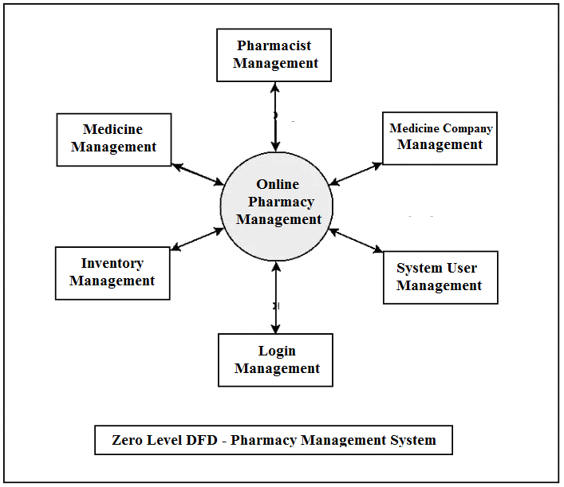

**DFD Level 2**

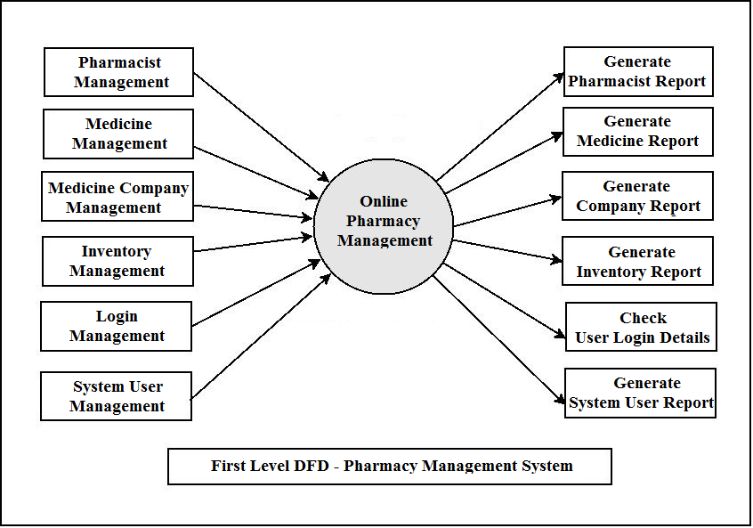

**//use caption with every figure**

**ER DIAGRAM**

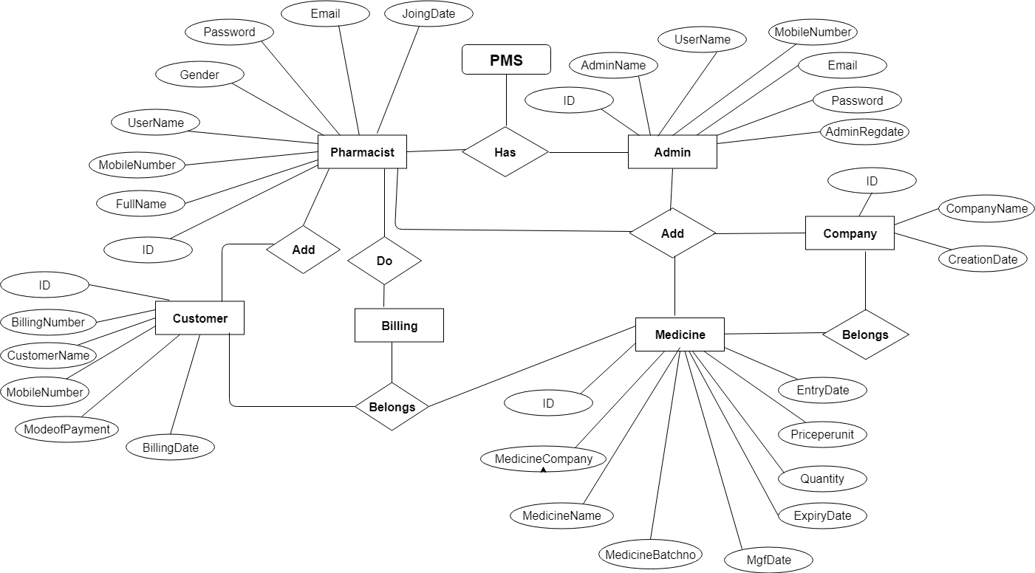

**Sequence Diagram For Administrator:-**

Fig.5.4

**Sequence Diagram For User:-**

**:**

Fig.5.5

* **Databse Design**

The data in the system has to be stored and retrieved from database. Designing the database is part of system design. Data elements and data structures to be stored have been identified at analysis stage. They are structured and put together to design the data storage and retrieval system.

A database is a collection of interrelated data stored with minimum redundancy to serve many users quickly and efficiently. The general objective is to make database access easy, quick, inexpensive and flexible for the user. Relationships are established between the data items and unnecessary data items are removed. Normalization is done to get an internal consistency of data and to have minimum redundancy and maximum stability. This ensures minimizing data storage required, minimizing chances of data inconsistencies and optimizing for updates. The Mysql database has been chosen for developing the relevant databases.

**Database tables**

In this project various tables used for maintain the information.

[**tbladmin**](http://localhost/phpmyadmin/sql.php?db=camsdb&token=0cdfa1f46252d35aec9fa851dd4c03bb&goto=db_structure.php&table=tbladmin&pos=0) **:** This table use to store admin login details.

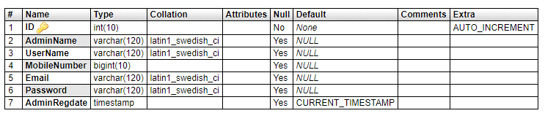

**tblcompany :** This table use to store medicine company details.

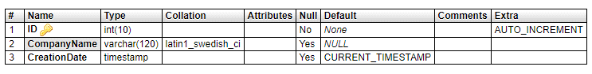

**tblmedicine :** This table use to store medicine details.

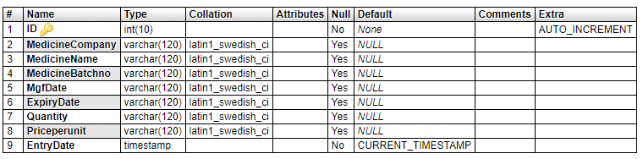

**tblpharmacist:** This table use to store pharmacist login details.

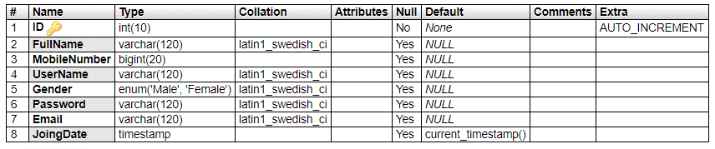

**tblcart:** This table use to store billing medicine details.

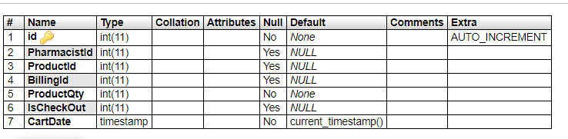

**tblcustomer:** This table use to store customer and final billing details.

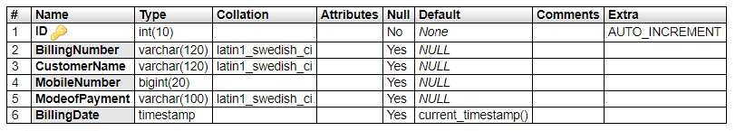

**Tables Relationship (Class Diagram)**

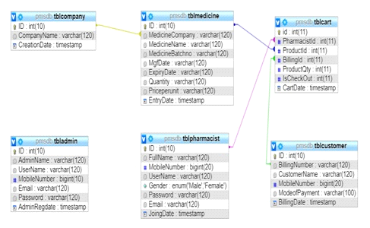

**CHAPTER # 6**

**Output screens**

**HOME PAGE**

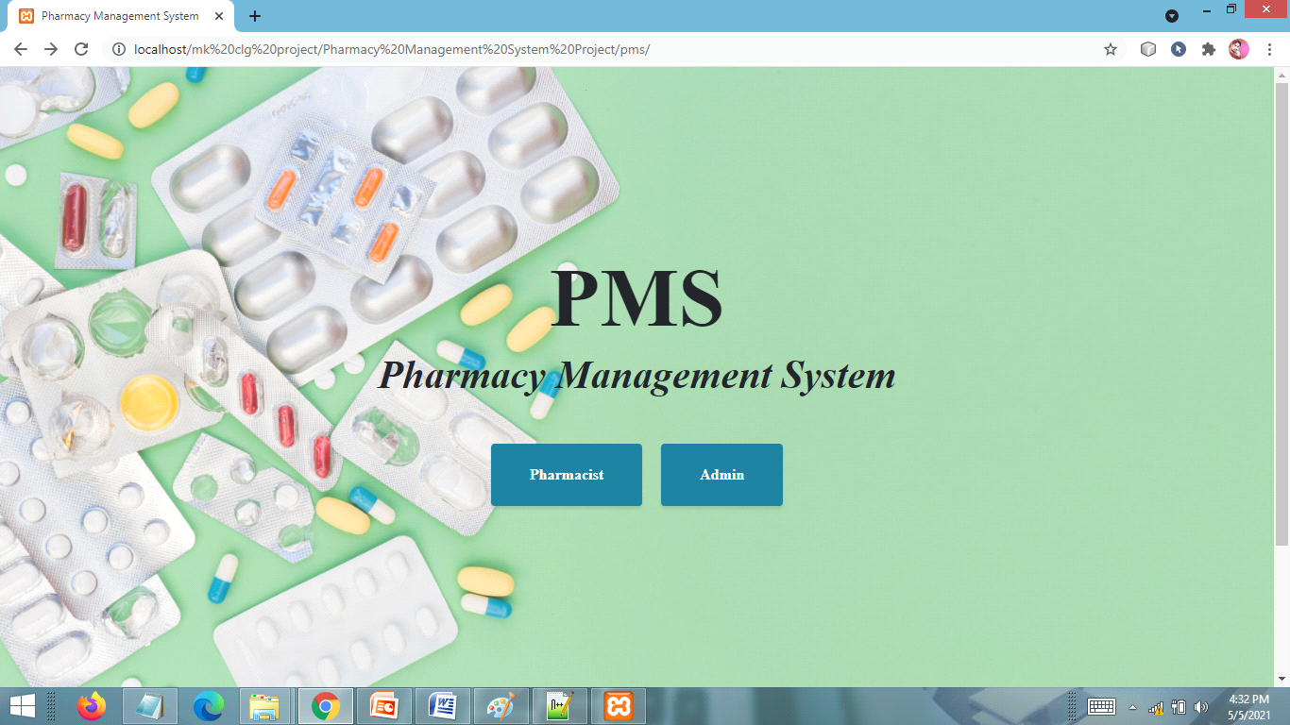

**ADMIN LOGIN PAGE**

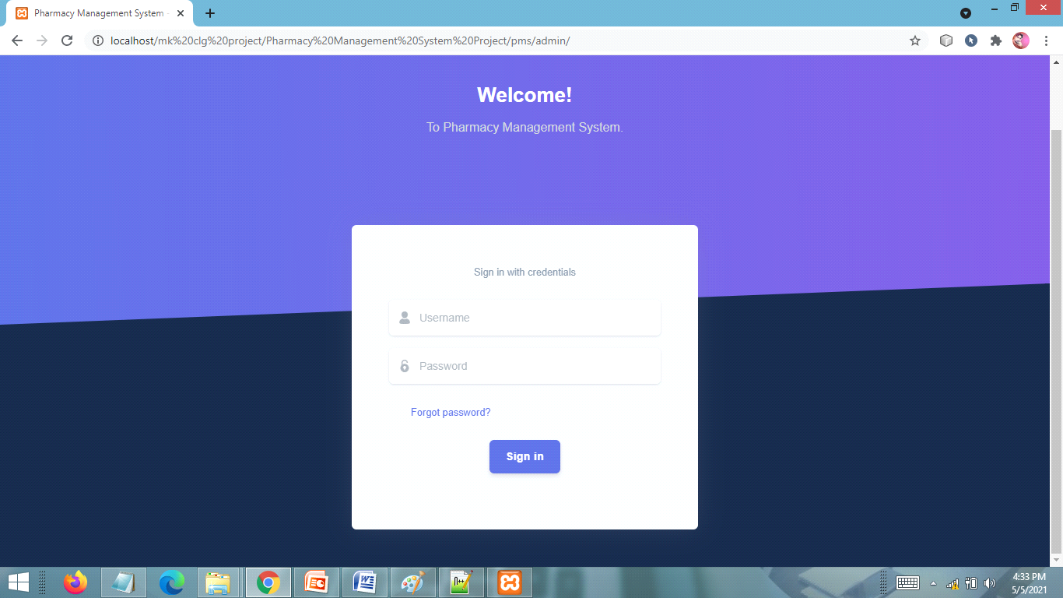

**ADMIN DASHBOARD PAGE**

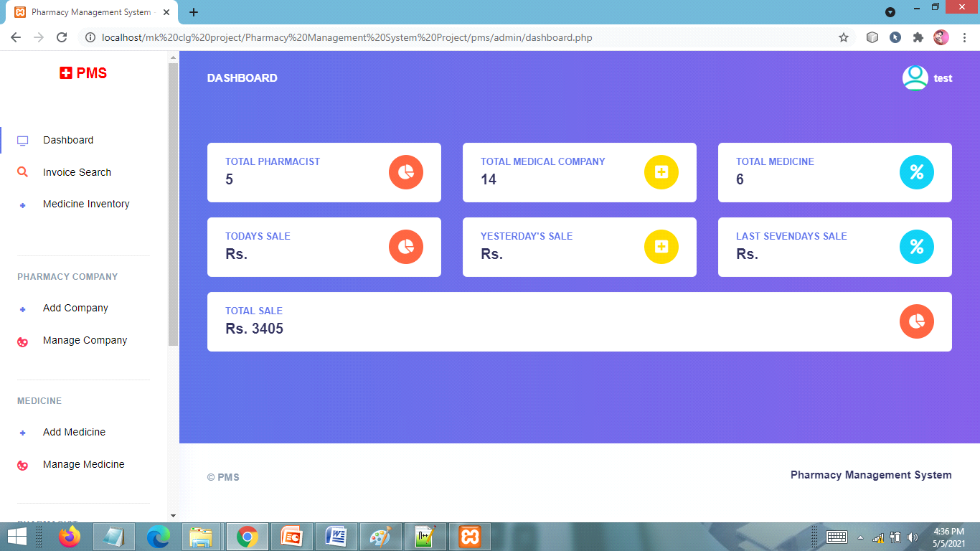

**INVOICE SEARCH PAGE**

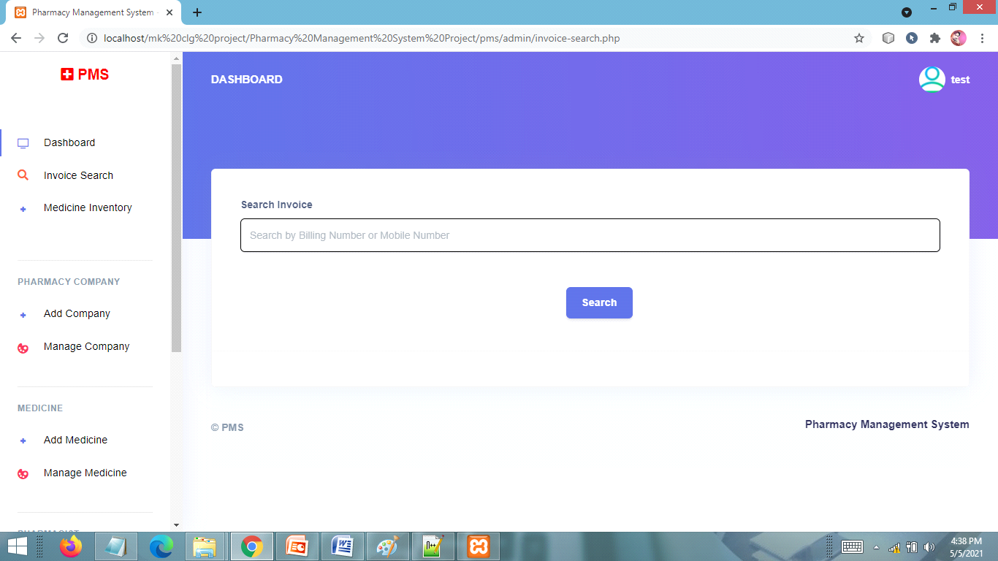

**MEDICINE INVENTORY PAGE**

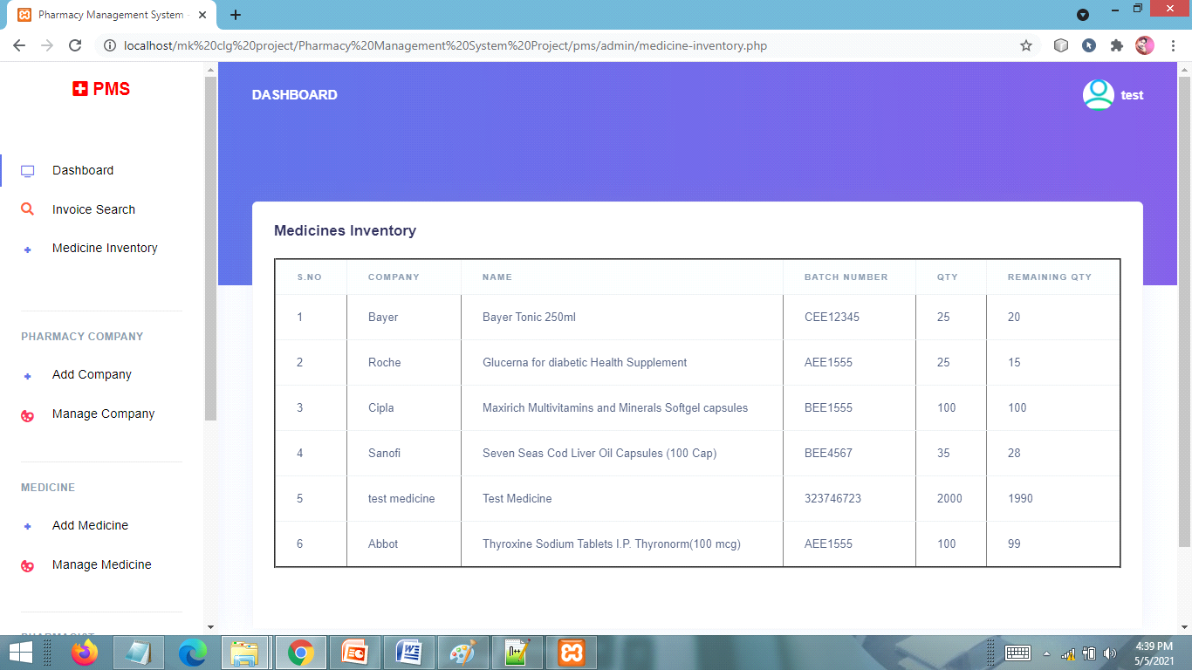

**ADD PHARMACY COMPANY PAGE**

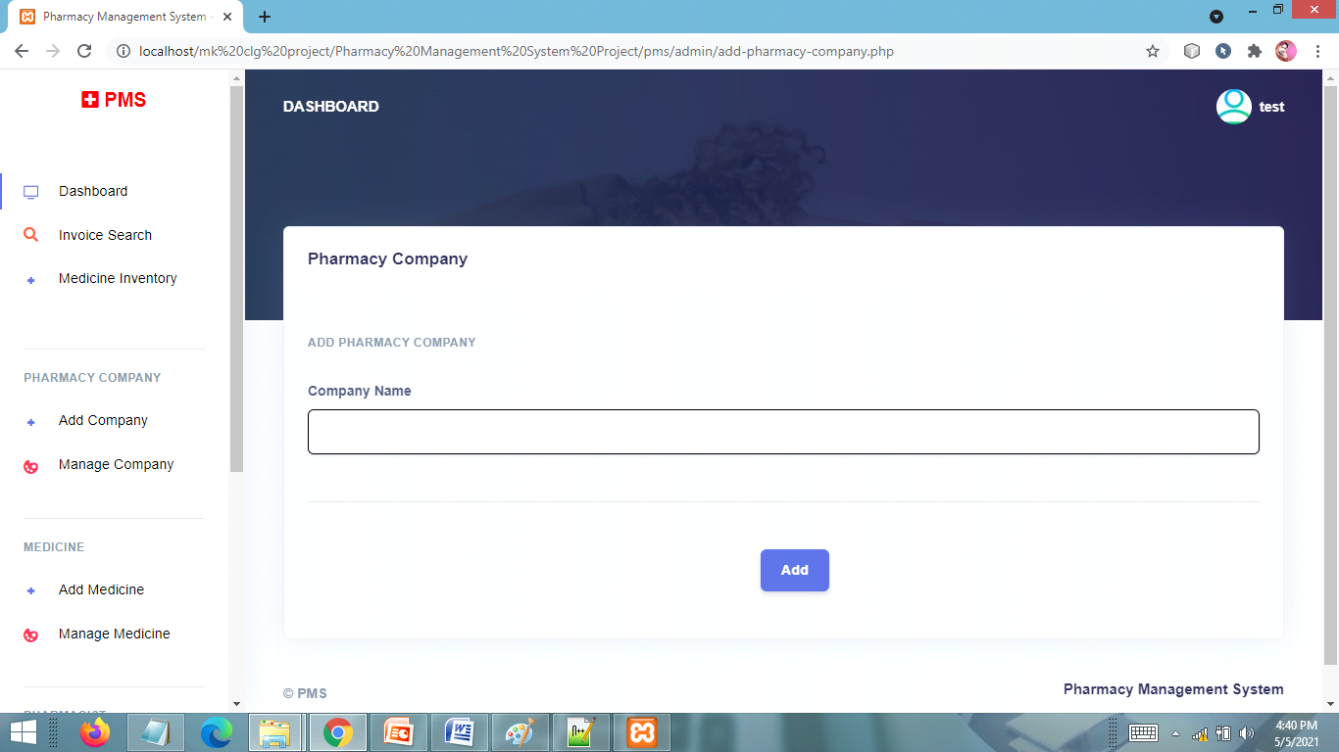

**MANAGE PHARMACY COMPANY PAGE**

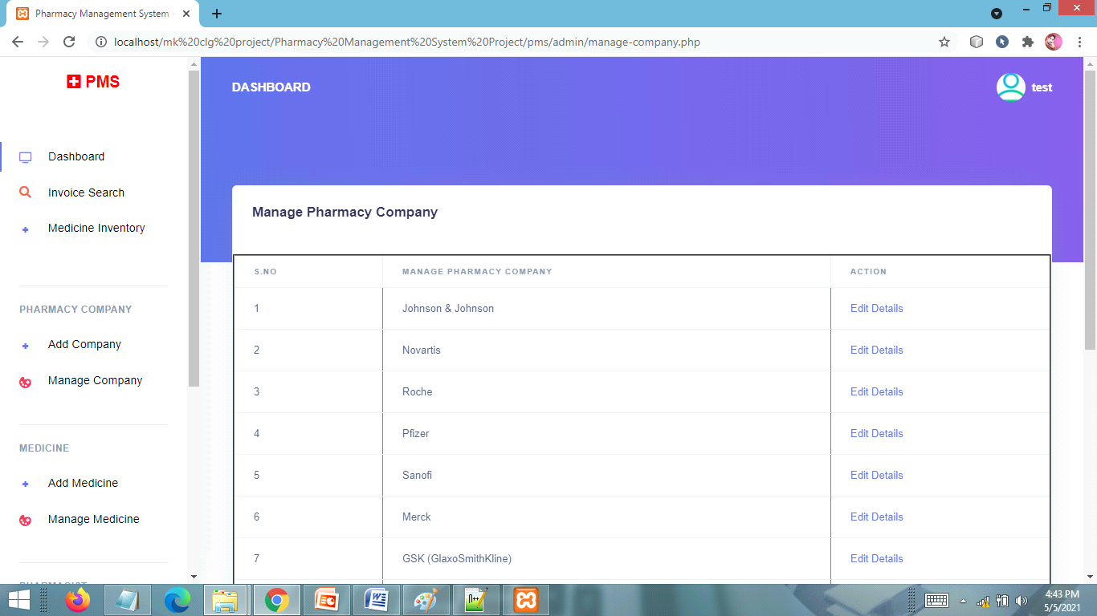

**ADD MEDICINE PAGE**

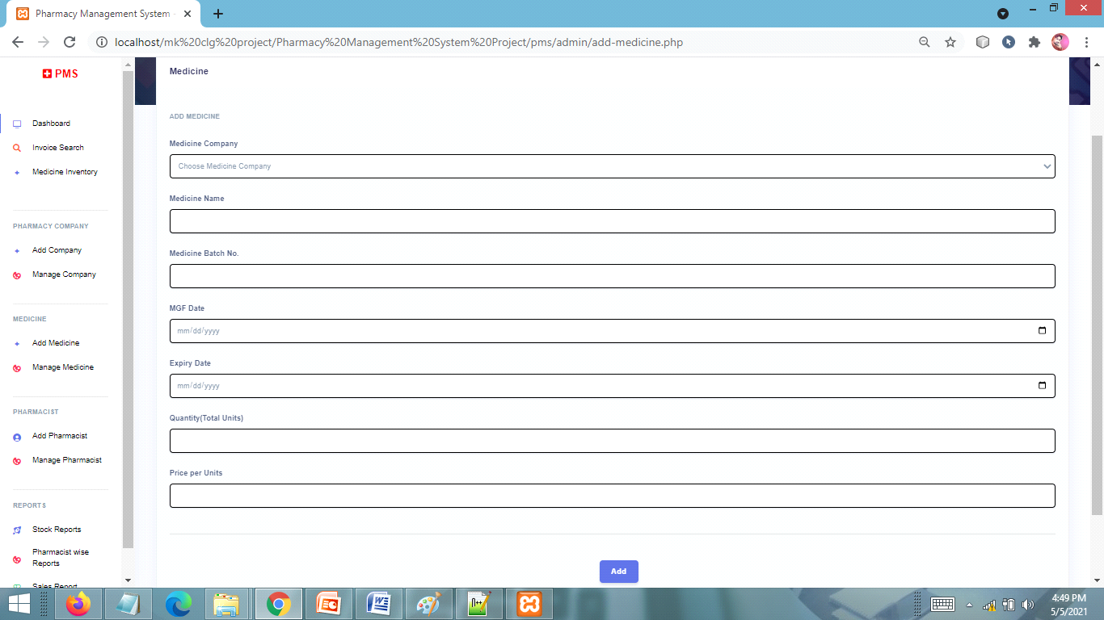

**MANAGE MEDICINE PAGE**

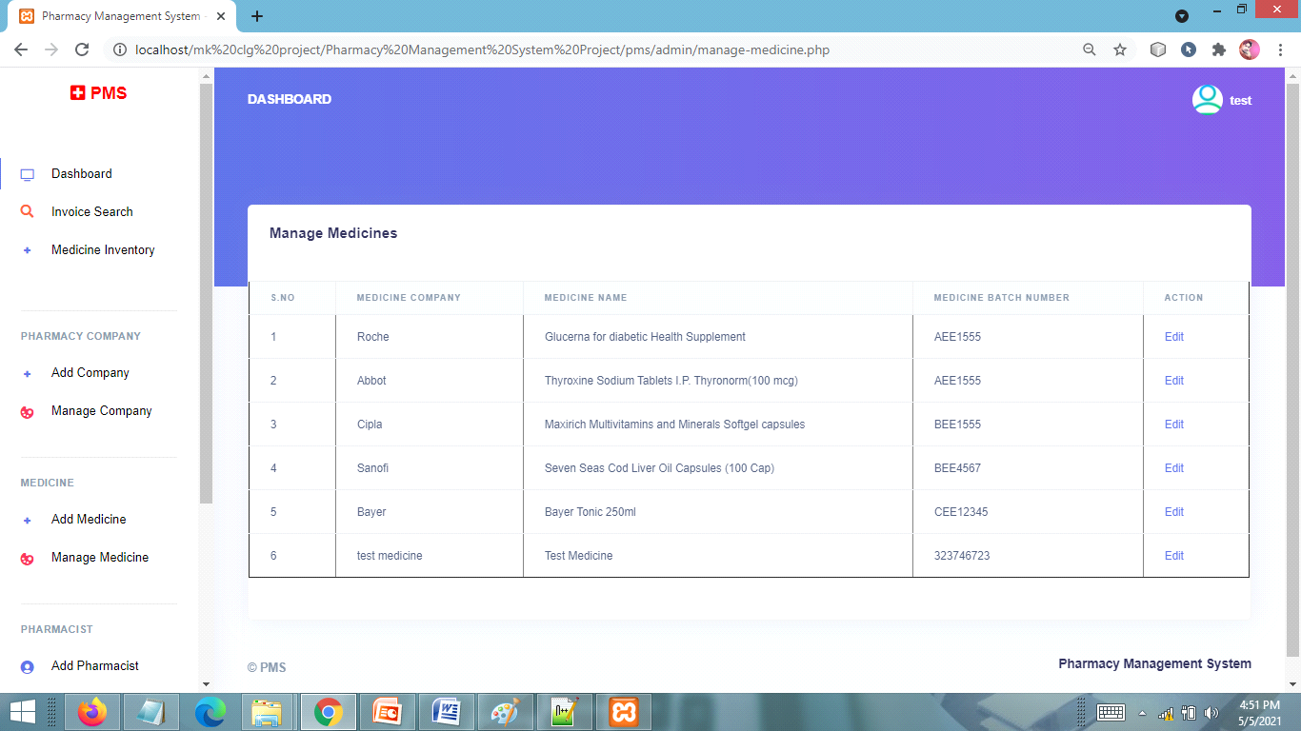

**ADD PHARMACIST DETAIL PAGE**

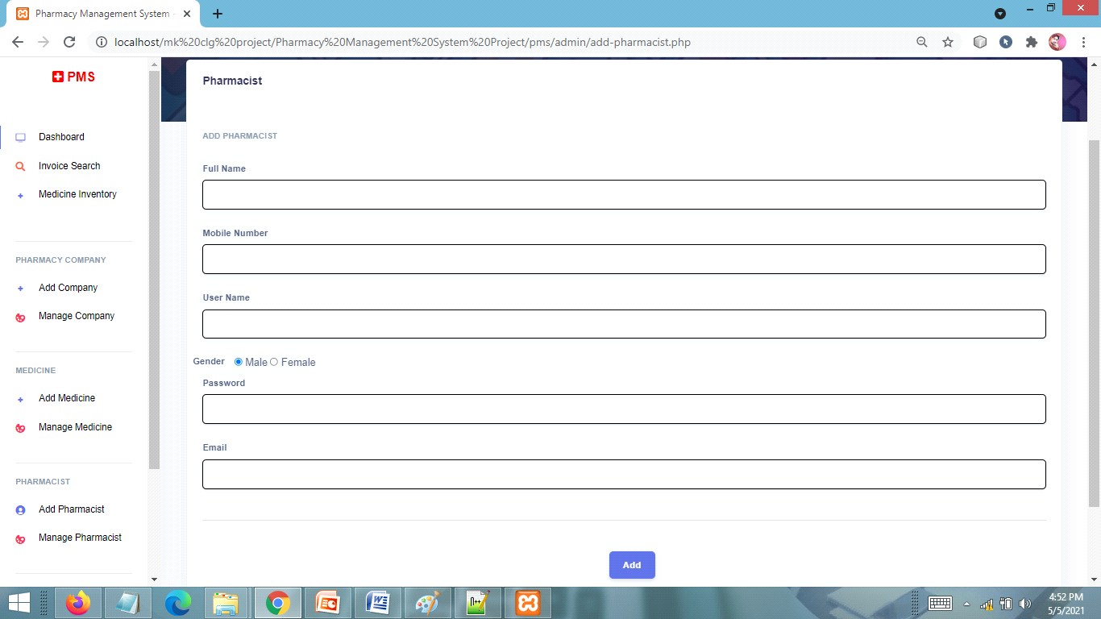

**MANAGE PHARMACIST PAGE**

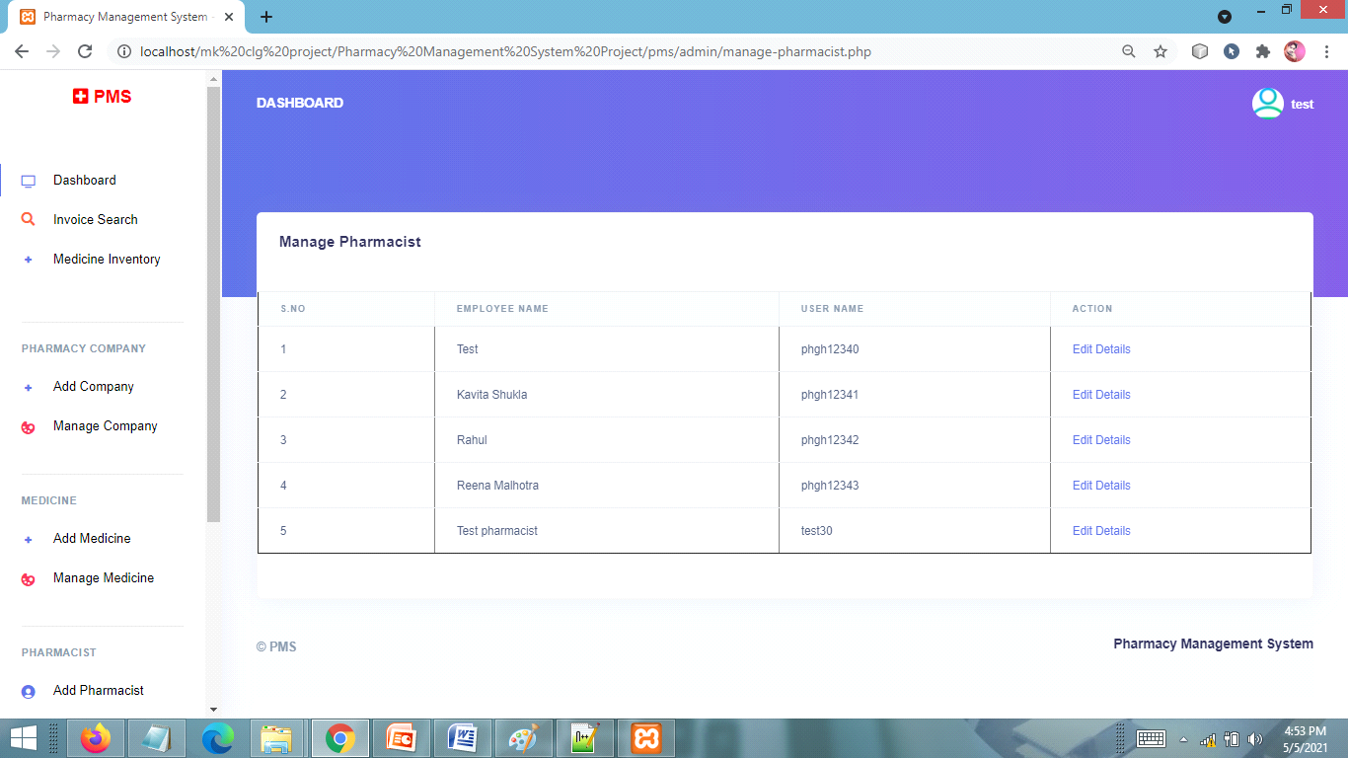

**PHARMACIST LOGIN PAGE**

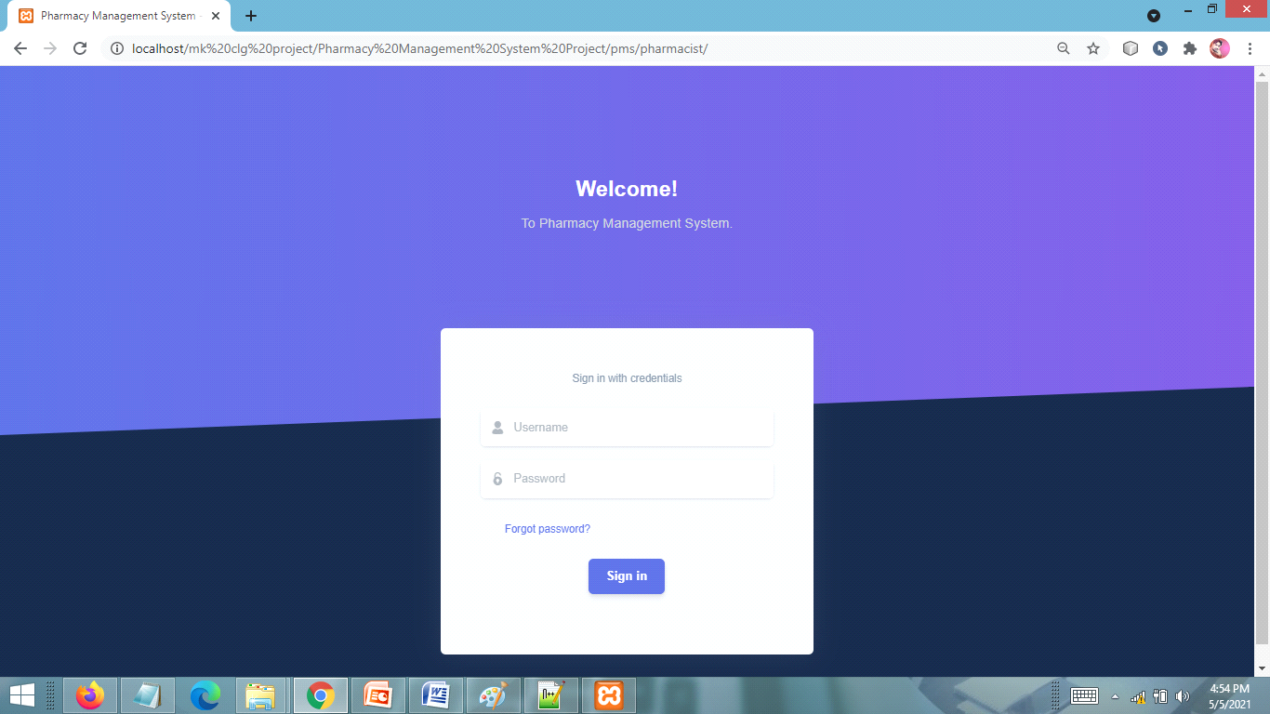

**PHARMACIST DASHBOARD PAGE**

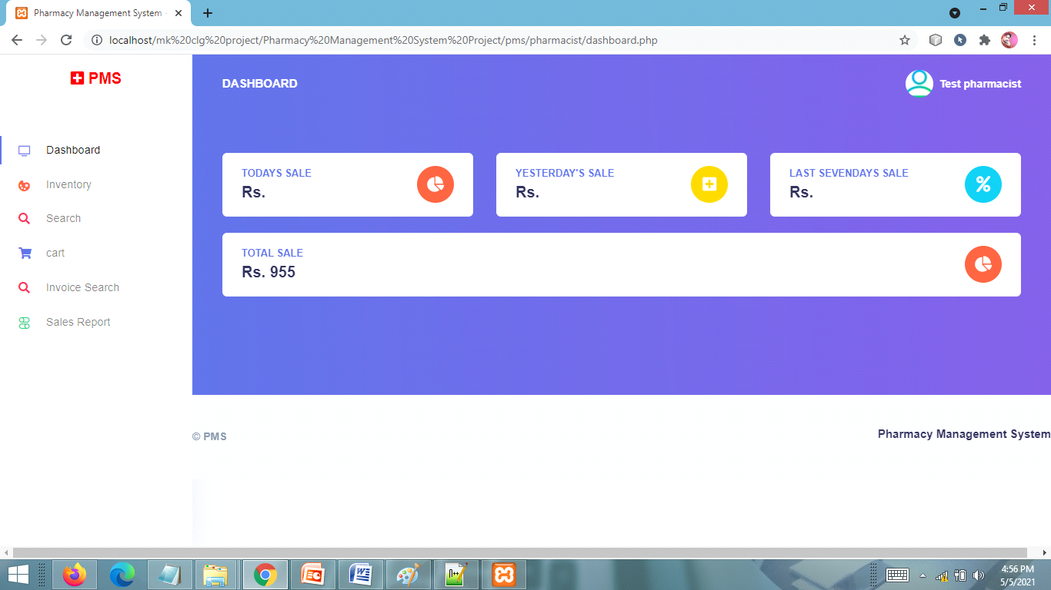

**INVENTORY PAGE**

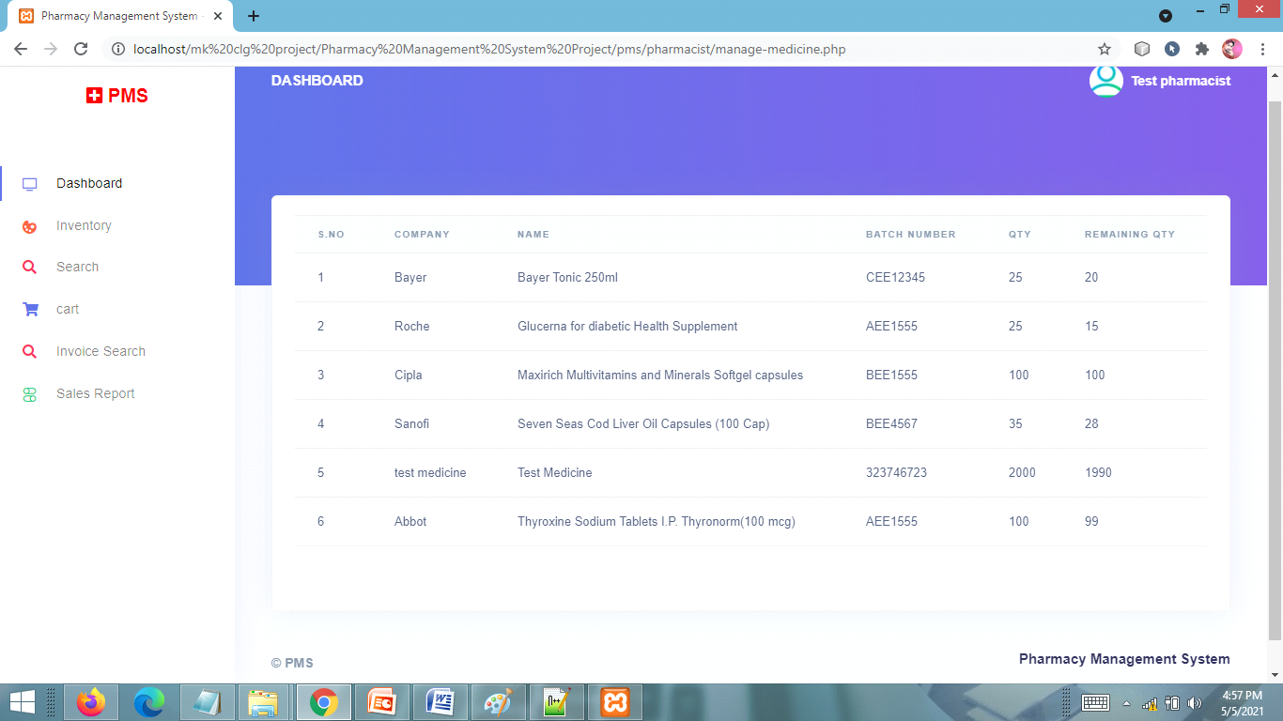

**SEARCH MEDICINE PAGE**

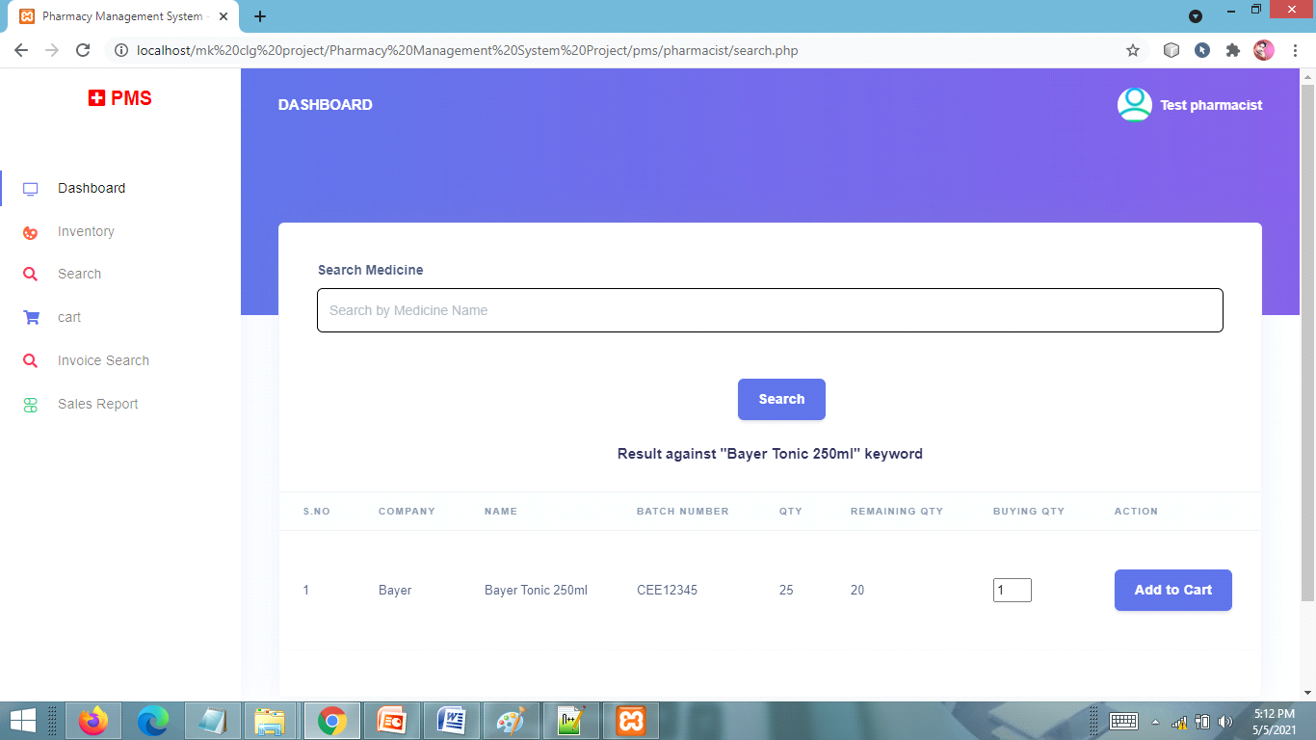

**CART PAGE**

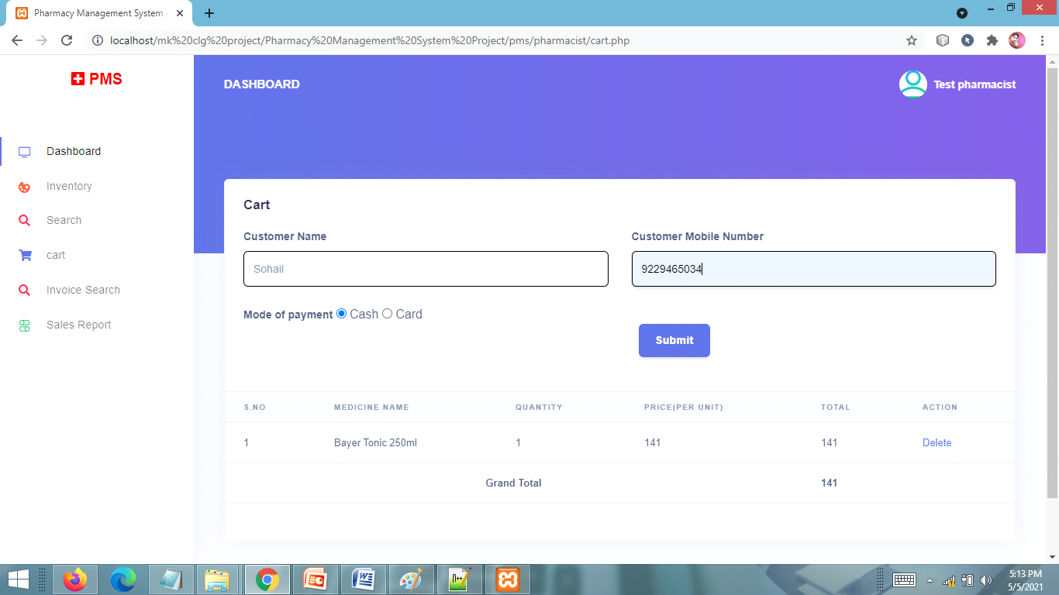

**PRINT INVOICE PAGE**

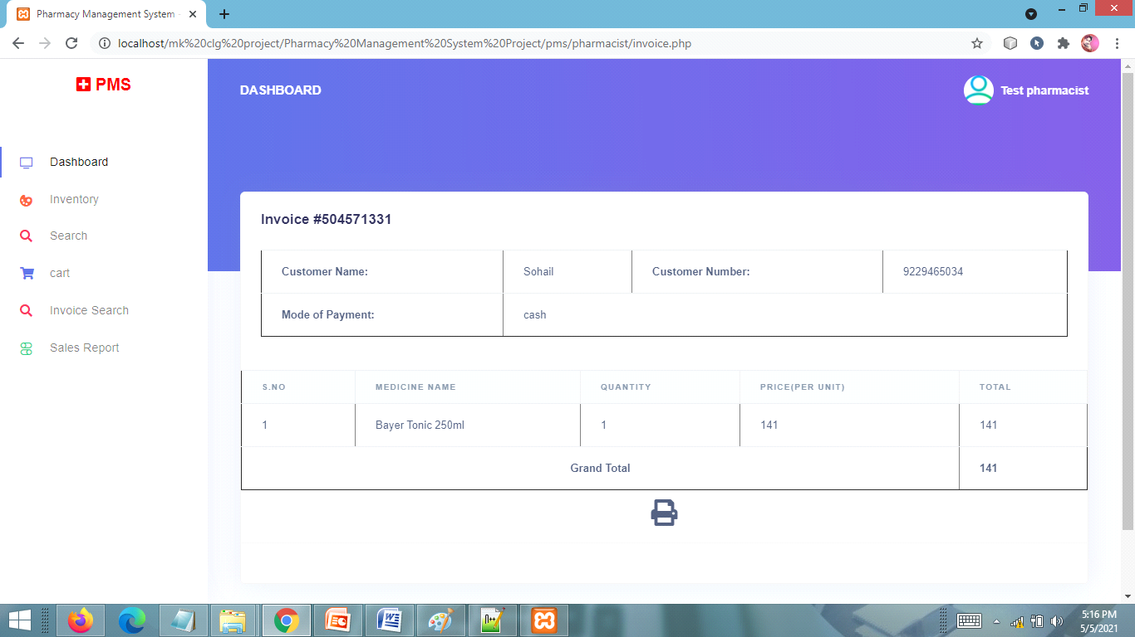

**CHAPTER # 7**

***Coding***

**HOME PAGE CODING**

<!DOCTYPE html>

<html lang="en">

<head>

<meta charset="utf-8">

<meta name="viewport" content="width=device-width, initial-scale=1, shrink-to-fit=no">

<meta name="description" content="">

<meta name="author" content="">

<title>Pharmacy Management System</title>

<!-- Bootstrap Core CSS -->

<link href="vendor/bootstrap/css/bootstrap.min.css" rel="stylesheet">

<!-- Custom Fonts -->

<link href="vendor/fontawesome-free/css/all.min.css" rel="stylesheet" type="text/css">

<link href="https://fonts.googleapis.com/css?family=Source+Sans+Pro:300,400,700,300italic,400italic,700italic" rel="stylesheet" type="text/css">

<link href="vendor/simple-line-icons/css/simple-line-icons.css" rel="stylesheet">

<!-- Custom CSS -->

<link href="css/stylish-portfolio.min.css" rel="stylesheet">

</head>

<body id="page-top">

<!-- Header -->

<header class="masthead d-flex">

<div class="container text-center my-auto">

<h1 class="mb-1">PMS</h1>

<h3 class="mb-5">

<em style="font-size:42px !important;">Pharmacy Management System</em>

</h3>

<a class="btn btn-primary btn-xl js-scroll-trigger" href="pharmacist/">Pharmacist</a>&nbsp;&nbsp;&nbsp;&nbsp;

<a class="btn btn-primary btn-xl js-scroll-trigger" href="admin">Admin</a>

</div>

<div class="overlay"></div>

</header>

<!-- Footer -->

<footer class="footer text-center">

<div class="container">

</ul>

<p class="text-muted small mb-0">Copyright &copy; PMS 2019</p>

</div>

</footer>

<!-- Scroll to Top Button-->

<a class="scroll-to-top rounded js-scroll-trigger" href="#page-top">

<i class="fas fa-angle-up"></i>

</a>

<!-- Bootstrap core JavaScript -->

<script src="vendor/jquery/jquery.min.js"></script>

<script src="vendor/bootstrap/js/bootstrap.bundle.min.js"></script>

<!-- Plugin JavaScript -->

<script src="vendor/jquery-easing/jquery.easing.min.js"></script>

<!-- Custom scripts for this template -->

<script src="js/stylish-portfolio.min.js"></script>

</body>

</html>

**ADMIN LOGIN PAGE CODING**

<?php

session_start();

error_reporting(0);

include('includes/dbconnection.php');

if(isset($_POST['login']))

{

$adminuser=$_POST['username'];

$password=md5($_POST['password']);

$query=mysqli_query($con,"select ID from tbladmin where UserName='$adminuser' && Password='$password' ");

$ret=mysqli_fetch_array($query);

if($ret>0){

$_SESSION['pmsaid']=$ret['ID'];

header('location:dashboard.php');

}

else{

$msg="Invalid Details.";

}

}

?>

<!DOCTYPE html>

<html lang="en">

<head>

<title>

Pharmacy Management System - Login Page

</title>

<!-- Fonts -->

<link href="https://fonts.googleapis.com/css?family=Open+Sans:300,400,600,700" rel="stylesheet">

<!-- Icons -->

<link href="assets/js/plugins/nucleo/css/nucleo.css" rel="stylesheet" />

<link href="assets/js/plugins/@fortawesome/fontawesome-free/css/all.min.css" rel="stylesheet" />

<!-- CSS Files -->

<link href="assets/css/argon-dashboard.css?v=1.1.0" rel="stylesheet" />

</head>

<body class="bg-default">

<div class="main-content">

<!-- Header -->

<div class="header bg-gradient-primary py-7 py-lg-8">

<div class="container">

<div class="header-body text-center mb-7">

<div class="row justify-content-center">

<div class="col-lg-5 col-md-6">

<h1 class="text-white">Welcome!</h1>

<p class="text-lead text-light">To Pharmacy Management System.</p>

</div>

</div>

</div>

</div>

<div class="separator separator-bottom separator-skew zindex-100">

<svg x="0" y="0" viewBox="0 0 2560 100" preserveAspectRatio="none" version="1.1" xmlns="http://www.w3.org/2000/svg">

<polygon class="fill-default" points="2560 0 2560 100 0 100"></polygon>

</svg>

</div>

</div>

<!-- Page content -->

<div class="container mt--8 pb-5">

<div class="row justify-content-center">

<div class="col-lg-5 col-md-7">

<div class="card bg-secondary shadow border-0">

<div class="card-body px-lg-5 py-lg-5">

<div class="text-center text-muted mb-4">

<small>Sign in with credentials</small>

</div>

<form role="form" method="post" action="">

<p style="font-size:16px; color:red" align="center"> <?php if($msg){

echo $msg;

} ?> </p>

<div class="form-group mb-3">

<div class="input-group input-group-alternative">

<div class="input-group-prepend">

<span class="input-group-text"><i class="ni ni-single-02"></i></span>

</div>

<input class="form-control" type="text" placeholder="Username" required="true" name="username">

</div>

</div>

<div class="form-group">

<div class="input-group input-group-alternative">

<div class="input-group-prepend">

<span class="input-group-text"><i class="ni ni-lock-circle-open"></i></span>

</div>

<input type="password" class="form-control" name="password" placeholder="Password" required="true">

</div>

</div>

<div class="custom-control custom-control-alternative custom-checkbox">

<input class="custom-control-input" id=" customCheckLogin" type="checkbox">

<a href="forgot-password.php" class="text-lead"><small>Forgot password?</small></a>

</div>

<div class="text-center">

<button class="btn btn-primary my-4" type="submit" name="login">Sign in</button>

</div>

</form>

</div>

</div>

</div>

</div>

</div>

</div>

<!-- Core -->

<script src="assets/js/plugins/jquery/dist/jquery.min.js"></script>

<script src="assets/js/plugins/bootstrap/dist/js/bootstrap.bundle.min.js"></script>

<!-- Optional JS -->

<!-- Argon JS -->

<script src="assets/js/argon-dashboard.min.js?v=1.1.0"></script>

<script src="https://cdn.trackjs.com/agent/v3/latest/t.js"></script>

<script>

window.TrackJS &&

TrackJS.install({

token: "ee6fab19c5a04ac1a32a645abde4613a",

application: "argon-dashboard-free"

});

</script>

</body>

</html>

**ADMIN DASHBOARD PAGE CODING**

<?php

session_start();

error_reporting(0);

include('includes/dbconnection.php');

if (strlen($_SESSION['pmsaid']==0)) {

header('location:logout.php');

} else{

?>

<!DOCTYPE html>

<html lang="en">

<head>

<title>

Pharmacy Management System - Admin Dashboard

</title>

<!-- Fonts -->

<link href="https://fonts.googleapis.com/css?family=Open+Sans:300,400,600,700" rel="stylesheet">

<!-- Icons -->

<link href="assets/js/plugins/nucleo/css/nucleo.css" rel="stylesheet" />

<link href="assets/js/plugins/@fortawesome/fontawesome-free/css/all.min.css" rel="stylesheet" />

<!-- CSS Files -->

<link href="assets/css/argon-dashboard.css?v=1.1.0" rel="stylesheet" />

</head>

<body class="">

<?php include_once('includes/navbar.php');?>

<div class="main-content">

<!-- Navbar -->

<?php include_once('includes/sidebar.php');?>

<!-- End Navbar -->

<!-- Header -->

<div class="header bg-gradient-primary pb-8 pt-5 pt-md-8">

<div class="container-fluid">

<div class="header-body">

<!-- Card stats -->

<div class="row">

<div class="col-xl-4 col-lg-6">

<div class="card card-stats mb-4 mb-xl-0">

<div class="card-body">

<div class="row">

<?php $query1=mysqli_query($con,"Select * from tblpharmacist");

$pharcount=mysqli_num_rows($query1);

?>

<div class="col">

<h5 class="card-title text-uppercase text-muted mb-0"><a href="manage-pharmacist.php">Total Pharmacist</a></h5>

<span class="h2 font-weight-bold mb-0"><?php echo $pharcount;?></span>

</div>

<div class="col-auto">

<div class="icon icon-shape bg-warning text-white rounded-circle shadow">

<i class="fas fa-chart-pie"></i>

</div>

</div>

</div>

</div>

</div>

</div>

<div class="col-xl-4 col-lg-6">

<div class="card card-stats mb-4 mb-xl-0">

<div class="card-body">

<div class="row">

<?php $query=mysqli_query($con,"Select * from tblcompany");

$compcount=mysqli_num_rows($query);

?>

<div class="col">

<h5 class="card-title text-uppercase text-muted mb-0"><a href="manage-company.php">Total Medical Company</a></h5>

<span class="h2 font-weight-bold mb-0"><?php echo $compcount;?></span>

</div>

<div class="col-auto">

<div class="icon icon-shape bg-yellow text-white rounded-circle shadow">

<i class="fa fa-plus-square"></i>

</div>

</div>

</div>

</div>

</div>

</div>

<div class="col-xl-4 col-lg-6">

<div class="card card-stats mb-4 mb-xl-0">

<div class="card-body">

<div class="row">

<?php $query2=mysqli_query($con,"Select * from tblmedicine");

$medcount=mysqli_num_rows($query2);

?>

<div class="col">

<h5 class="card-title text-uppercase text-muted mb-0"><a href="manage-medicine.php">Total Medicine</a> </h5>

<span class="h2 font-weight-bold mb-0"><?php echo $medcount;?></span>

</div>

<div class="col-auto">

<div class="icon icon-shape bg-info text-white rounded-circle shadow">

<i class="fas fa-percent"></i>

</div>

</div>

</div>

</div>

</div>

</div>

</div>

<div class="row" style="margin-top:2%">

<div class="col-xl-4 col-lg-6" >

<div class="card card-stats mb-4 mb-xl-0">

<div class="card-body">

<div class="row">

<?php

//todays sale

$query4=mysqli_query($con,"select tblcart.ProductQty as ProductQty,tblmedicine.Priceperunit

from tblcart

join tblmedicine on tblmedicine.ID=tblcart.ProductId where date(CartDate)=CURDATE();");

while($row=mysqli_fetch_array($query4))

{

$todays_sale=$row['ProductQty']*$row['Priceperunit'];

$todysale+=$todays_sale;

}

?>

<div class="col">

<h5 class="card-title text-uppercase text-muted mb-0"><a href="sales-reports.php">todays sale</a></h5>

<span class="h2 font-weight-bold mb-0">Rs. <?php echo $todysale;?></span>

</div>

<div class="col-auto">

<div class="icon icon-shape bg-warning text-white rounded-circle shadow">

<i class="fas fa-chart-pie"></i>

</div>

</div>

</div>

</div>

</div>

</div>

<div class="col-xl-4 col-lg-6">

<div class="card card-stats mb-4 mb-xl-0">

<div class="card-body">

<div class="row">

<?php

//Yesterday's sale

$query5=mysqli_query($con,"select tblcart.ProductQty as ProductQty,tblmedicine.Priceperunit

from tblcart

join tblmedicine on tblmedicine.ID=tblcart.ProductId where date(CartDate)=CURDATE()-1;");

while($row5=mysqli_fetch_array($query5))

{

$yesterdays_sale=$row5['ProductQty']*$row5['Priceperunit'];

$yesterdaysale+=$yesterdays_sale;

}

?>

<div class="col">

<h5 class="card-title text-uppercase text-muted mb-0"><a href="sales-reports.php">Yesterday's sale</a></h5>

<span class="h2 font-weight-bold mb-0">Rs. <?php echo $yesterdaysale;?></span>

</div>

<div class="col-auto">

<div class="icon icon-shape bg-yellow text-white rounded-circle shadow">

<i class="fa fa-plus-square"></i>

</div>

</div>

</div>

</div>

</div>

</div>

<div class="col-xl-4 col-lg-6">

<div class="card card-stats mb-4 mb-xl-0">

<div class="card-body">

<div class="row">

<?php

//Last Sevendays Sale

$query6=mysqli_query($con,"select tblcart.ProductQty as ProductQty,tblmedicine.Priceperunit

from tblcart

join tblmedicine on tblmedicine.ID=tblcart.ProductId where date(CartDate)>=(DATE(NOW()) - INTERVAL 7 DAY);");

while($row2=mysqli_fetch_array($query6))

{

$sevendays_sale=$row2['ProductQty']*$row2['Priceperunit'];

$tseven+=$sevendays_sale;

}

?>

<div class="col">

<h5 class="card-title text-uppercase text-muted mb-0"><a href="sales-reports.php">Last Sevendays Sale</a> </h5>

<span class="h2 font-weight-bold mb-0">Rs. <?php echo $tseven;?></span>

</div>

<div class="col-auto">

<div class="icon icon-shape bg-info text-white rounded-circle shadow">

<i class="fas fa-percent"></i>

</div>

</div>

</div>

</div>

</div>

</div>

</div>

<div class="row" style="margin-top:2%">

<div class="col-xl-12 col-lg-6" >

<div class="card card-stats mb-4 mb-xl-0">

<div class="card-body">

<div class="row">

<?php

//Total Sale

$query7=mysqli_query($con,"select tblcart.ProductQty as ProductQty,tblmedicine.Priceperunit

from tblcart

join tblmedicine on tblmedicine.ID=tblcart.ProductId");

while($row7=mysqli_fetch_array($query7))

{

$total_sale=$row7['ProductQty']*$row7['Priceperunit'];

$totalsale+=$total_sale;

}

?>

<div class="col">

<h5 class="card-title text-uppercase text-muted mb-0"><a href="sales-reports.php">Total sale</a></h5>

<span class="h2 font-weight-bold mb-0">Rs. <?php echo $totalsale;?></span>

</div>

<div class="col-auto">

<div class="icon icon-shape bg-warning text-white rounded-circle shadow">

<i class="fas fa-chart-pie"></i>

</div>

</div>

</div>

</div>

</div>

</div>

</div>

</div>

</div>

</div>

<div class="container-fluid mt--7">

<div class="row mt-5">

<div class="card-header border-0">

</div>

<div class="table-responsive">

<!-- Projects table -->

</div>

</div>

<div class="col-xl-4">

</div>

<?php include_once('includes/footer.php');?>

</div>

</div>

<!-- Core -->

<script src="assets/js/plugins/jquery/dist/jquery.min.js"></script>

<script src="assets/js/plugins/bootstrap/dist/js/bootstrap.bundle.min.js"></script>

<!-- Optional JS -->

<script src="assets/js/plugins/chart.js/dist/Chart.min.js"></script>

<script src="assets/js/plugins/chart.js/dist/Chart.extension.js"></script>

<!-- Argon JS -->

<script src="assets/js/argon-dashboard.min.js?v=1.1.0"></script>

<script src="https://cdn.trackjs.com/agent/v3/latest/t.js"></script>

<script>

window.TrackJS &&

TrackJS.install({

token: "ee6fab19c5a04ac1a32a645abde4613a",

application: "argon-dashboard-free"

});

</script>

</body>

</html>

<?php }?>

**ADD MEDICINE PAGE**

**<?php**

**session_start();**

**error_reporting(0);**

include('includes/dbconnection.php');

if (strlen($_SESSION['pmsaid']==0)) {

header('location:logout.php');

} else{

if(isset($_POST['submit']))

{

$compname=$_POST['compname'];

$medname=$_POST['medname'];

$batchnumber=$_POST['batchnumber'];

$mgfdate=$_POST['mgfdate'];

$expirydate=$_POST['expirydate'];

$quantity=$_POST['quantity'];

$price=$_POST['price'];

$query=mysqli_query($con, "insert into tblmedicine(MedicineCompany,MedicineName,MedicineBatchno,MgfDate,ExpiryDate,Quantity,Priceperunit) value('$compname','$medname','$batchnumber','$mgfdate','$expirydate','$quantity','$price')");

if ($query) {

echo "<script>alert('Medicine has been added.');</script>";

echo "<script>window.location.href ='add-medicine.php'</script>";

}

else

{

$msg="Something Went Wrong. Please try again";

}

}

?>

<!DOCTYPE html>

<html lang="en">

<head>

<title>

Pharmacy Management System - Add Medicine

</title>

<!-- Fonts -->

<link href="https://fonts.googleapis.com/css?family=Open+Sans:300,400,600,700" rel="stylesheet">

<!-- Icons -->

<link href="assets/js/plugins/nucleo/css/nucleo.css" rel="stylesheet" />

<link href="assets/js/plugins/@fortawesome/fontawesome-free/css/all.min.css" rel="stylesheet" />

<!-- CSS Files -->

<link href="assets/css/argon-dashboard.css?v=1.1.0" rel="stylesheet" />

</head>

<body class="">

<?php include_once('includes/navbar.php');?>

<div class="main-content">

<!-- Navbar -->

<?php include_once('includes/sidebar.php');?>

<!-- End Navbar -->

<!-- Header -->

<div class="header pb-8 pt-5 pt-lg-8 d-flex align-items-center" style="min-height: 30px; background-image: url(assets/img/theme/pharmacy.jpg); background-size: cover; background-position: center top;">

<!-- Mask -->

<span class="mask bg-gradient-default opacity-8"></span>

<!-- Header container -->

</div>

<!-- Page content -->

<div class="container-fluid mt--7">

<div class="row">

<div class="col-xl-12 order-xl-1">

<div class="card bg-secondary shadow">

<div class="card-header bg-white border-0">

<div class="row align-items-center">

<div class="col-8">

<h3 class="mb-0">Medicine</h3>

</div>

</div>

</div>

<div class="card-body">

<form method="post" >

<p style="font-size:16px; color:red" align="center"> <?php if($msg){

echo $msg;

} ?> </p>

<h6 class="heading-small text-muted mb-4">Add Medicine</h6>

<div class="pl-lg-12">

<div class="row">

<div class="col-lg-12">

<div class="form-group">

<label class="form-control-label" for="input-username">Medicine Company</label>

<select class="form-control m-bot15" name="compname" id="compname" style="border:1px #000 solid;">

<option value="">Choose Medicine Company</option>

<?php $query=mysqli_query($con,"select * from tblcompany");

while($row=mysqli_fetch_array($query))

{

?>

<option value="<?php echo $row['CompanyName'];?>"><?php echo $row['CompanyName'];?></option>

<?php } ?>

</select>

</div>

</div>

<div class="col-lg-12">

<div class="form-group">

<label class="form-control-label" for="input-username">Medicine Name</label>

<input type="text" id="medname" name="medname" type="text" class="form-control form-control-alternative" value="" required="true" style="border:1px #000 solid;">

</div>

</div>

<div class="col-lg-12">

<div class="form-group">

<label class="form-control-label" for="input-username">Medicine Batch No.</label>

<input type="text" id="batchnumber" name="batchnumber" type="text" class="form-control form-control-alternative" value="" required="true" style="border:1px #000 solid;">

</div>

</div>

<div class="col-lg-12">

<div class="form-group">

<label class="form-control-label" for="input-username">MGF Date</label>

<input type="date" id="mgfdate" name="mgfdate" class="form-control form-control-alternative" value="" required="true" style="border:1px #000 solid;" >

</div>

</div>

<div class="col-lg-12">

<div class="form-group">

<label class="form-control-label" for="input-username">Expiry Date</label>

<input type="date" id="expirydate" name="expirydate" class="form-control form-control-alternative" value="" required="true" style="border:1px #000 solid;" >

</div>

</div>

<div class="col-lg-12">

<div class="form-group">

<label class="form-control-label" for="input-username">Quantity(Total Units)</label>

<input type="text" id="quantity" name="quantity" class="form-control form-control-alternative" value="" required="true" style="border:1px #000 solid;" >

</div>

</div>

<div class="col-lg-12">

<div class="form-group">

<label class="form-control-label" for="input-username">Price per Units</label>

<input type="text" id="price" name="price" class="form-control form-control-alternative" value="" required="true" style="border:1px #000 solid;" >

</div>

</div>

</div>

<div class="row">

</div>

</div>

<hr class="my-4" />

<!-- Description -->

<div class="pl-lg-4">

<div class="text-center">

<button class="btn btn-primary my-4" type="submit" name="submit">Add</button>

</div>

</div>

</form>

</div>

</div>

</div>

</div>

<!-- Footer -->

<?php include_once('includes/footer.php');?>

</div>

</div>

<!-- Core -->

<script src="assets/js/plugins/jquery/dist/jquery.min.js"></script>

<script src="assets/js/plugins/bootstrap/dist/js/bootstrap.bundle.min.js"></script>

<!-- Optional JS -->

<!-- Argon JS -->

<script src="assets/js/argon-dashboard.min.js?v=1.1.0"></script>

<script src="https://cdn.trackjs.com/agent/v3/latest/t.js"></script>

<script>

window.TrackJS &&

TrackJS.install({

token: "ee6fab19c5a04ac1a32a645abde4613a",

application: "argon-dashboard-free"

});

</script>

</body>

</html>

<?php } ?>

**MANAGE MEDICINE PAGE CODING**

<?php

session_start();

error_reporting(0);

include('includes/dbconnection.php');

if (strlen($_SESSION['pmsaid']==0)) {

header('location:logout.php');

} else{

?>

<!DOCTYPE html>

<html lang="en">

<head>

<title>

Pharmacy Management System - Manage Medicines

</title>

<!-- Fonts -->

<link href="https://fonts.googleapis.com/css?family=Open+Sans:300,400,600,700" rel="stylesheet">

<!-- Icons -->

<link href="assets/js/plugins/nucleo/css/nucleo.css" rel="stylesheet" />

<link href="assets/js/plugins/@fortawesome/fontawesome-free/css/all.min.css" rel="stylesheet" />

<!-- CSS Files -->

<link href="assets/css/argon-dashboard.css?v=1.1.0" rel="stylesheet" />

</head>

<body class="">

<?php include_once('includes/navbar.php');?>

<div class="main-content">

<!-- Navbar -->

<?php include_once('includes/sidebar.php');?>

<!-- End Navbar -->

<!-- Header -->

<div class="header bg-gradient-primary pb-8 pt-5 pt-md-8">

<div class="container-fluid">

<div class="header-body">

<!-- Card stats -->

</div>

</div>

</div>

<div class="container-fluid mt--7">

<!-- Table -->

<div class="row">

<div class="col">

<div class="card shadow">

<div class="card-header border-0">

<h3 class="mb-0">Manage Medicines</h3>

</div>

<div class="table-responsive" style="margin-top:2%">

<table class="table align-items-center" style="font-size:22px;" border="2">

<thead class="thead-light">

<tr>

<th scope="col">S.NO</th>

<th scope="col">Medicine Company</th>

<th scope="col">Medicine Name</th>

<th scope="col">Medicine Batch Number</th>

<th scope="col">Action</th>

</tr>

</thead>

<tbody>

<?php

$ret=mysqli_query($con,"select *from tblmedicine");

$cnt=1;

while ($row=mysqli_fetch_array($ret)) {

?>

<tr>

<td><?php echo $cnt;?></td>

<td><?php echo $row['MedicineCompany'];?></td>

<td><?php echo $row['MedicineName'];?></td>

<td><?php echo $row['MedicineBatchno'];?></td>

<td><a href="edit-medicine.php?editid=<?php echo $row['ID'];?>">Edit</a></td>

</tr>

<?php

$cnt=$cnt+1;

}?>

</tbody>

</table>

</div>

<div class="card-footer py-4">

</div>

</div>

</div>

</div>

<!-- Dark table -->

<!-- Footer -->

<?php include_once('includes/footer.php');?>

</div>

</div>

<!-- Core -->

<script src="assets/js/plugins/jquery/dist/jquery.min.js"></script>

<script src="assets/js/plugins/bootstrap/dist/js/bootstrap.bundle.min.js"></script>

<!-- Optional JS -->

<!-- Argon JS -->

<script src="assets/js/argon-dashboard.min.js?v=1.1.0"></script>

<script src="https://cdn.trackjs.com/agent/v3/latest/t.js"></script>

<script>

window.TrackJS &&

TrackJS.install({

token: "ee6fab19c5a04ac1a32a645abde4613a",

application: "argon-dashboard-free"

});

</script>

</body>

</html>

<?php } ?>

**ADD PHARMACIST PAGE CODING**

<?php

session_start();

error_reporting(0);

include('includes/dbconnection.php');

if (strlen($_SESSION['pmsaid']==0)) {

header('location:logout.php');

} else{

if(isset($_POST['submit']))

{

$fname=$_POST['fullname'];

$mobno=$_POST['mobnumber'];

$email=$_POST['email'];

$uname=$_POST['username'];

$gender=$_POST['gender'];

$password=md5($_POST['password']);

$ret=mysqli_query($con, "select UserName from tblpharmacist where UserName='$uname'");

$result=mysqli_fetch_array($ret);

if($result>0){

$msg="This user name already associated with another person";

}

else{

$query=mysqli_query($con, "insert into tblpharmacist(FullName,MobileNumber,UserName,Gender,Password,Email) value('$fname','$mobno','$uname','$gender','$password','$email')");

if ($query) {

$msg="Pharmacist detail has been added.";

}

else

{

$msg="Something Went Wrong. Please try again";

}

}

}

?>

<!DOCTYPE html>

<html lang="en">

<head>

<title>

Pharmacy Management System - Add Pharmacist

</title>

<!-- Fonts -->

<link href="https://fonts.googleapis.com/css?family=Open+Sans:300,400,600,700" rel="stylesheet">

<!-- Icons -->

<link href="assets/js/plugins/nucleo/css/nucleo.css" rel="stylesheet" />

<link href="assets/js/plugins/@fortawesome/fontawesome-free/css/all.min.css" rel="stylesheet" />

<!-- CSS Files -->

<link href="assets/css/argon-dashboard.css?v=1.1.0" rel="stylesheet" />

</head>

<body class="">

<?php include_once('includes/navbar.php');?>

<div class="main-content">

<!-- Navbar -->

<?php include_once('includes/sidebar.php');?>

<!-- End Navbar -->

<!-- Header -->

<div class="header pb-8 pt-5 pt-lg-8 d-flex align-items-center" style="min-height: 30px; background-image: url(assets/img/theme/pharmacy.jpg); background-size: cover; background-position: center top;">

<!-- Mask -->

<span class="mask bg-gradient-default opacity-8"></span>

<!-- Header container -->

</div>

<!-- Page content -->

<div class="container-fluid mt--7">

<div class="row">

<div class="col-xl-12 order-xl-1">

<div class="card bg-secondary shadow">

<div class="card-header bg-white border-0">

<div class="row align-items-center">

<div class="col-8">

<h3 class="mb-0">Pharmacist</h3>

</div>

</div>

</div>

<div class="card-body">

<form method="post">

<p style="font-size:16px; color:red" align="center"> <?php if($msg){

echo $msg;

} ?> </p>

<h6 class="heading-small text-muted mb-4">Add Pharmacist</h6>

<div class="pl-lg-12">

<div class="row">

<div class="col-lg-12">

<div class="form-group">

<label class="form-control-label" for="input-username">Full Name</label>

<input type="text" id="fullname" name="fullname" class="form-control form-control-alternative" value="" required="true" style="border:1px #000 solid;">

</div>

</div>

<div class="col-lg-12">

<div class="form-group">

<label class="form-control-label" for="input-username">Mobile Number</label>

<input type="text" id="mobnumber" name="mobnumber" class="form-control form-control-alternative" value="" required="true" maxlength="10" pattern="[0-9]+" style="border:1px #000 solid;">

</div>

</div>

<div class="col-lg-12">

<div class="form-group">

<label class="form-control-label" for="input-username">User Name</label>

<input type="text" id="username" name="username" class="form-control form-control-alternative" value="" required="true" style="border:1px #000 solid;" >

</div>

</div>

<label class="form-control-label" for="input-username">Gender</label>

<div class="col-lg-6">

<label class="checkbox-inline">

<input type="radio" id="gender" name="gender" value="Male" checked="true" required="true" > Male

</label>

<label class="checkbox-inline">

<input type="radio" id="gender" name="gender" value="Female" required="true"> Female

</label>

</div>

<div class="col-lg-12">

<div class="form-group">

<label class="form-control-label" for="input-username">Password</label>

<input id="password" name="password" type="password" class="form-control form-control-alternative" value="" required="true" style="border:1px #000 solid;">

</div>

</div>

<div class="col-lg-12">

<div class="form-group">

<label class="form-control-label" for="input-username">Email</label>

<input id="email" name="email" type="email" class="form-control form-control-alternative" value="" required="true" style="border:1px #000 solid;" >

</div>

</div>

</div>

<div class="row">

</div>

</div>

<hr class="my-4" />

<!-- Description -->

<div class="pl-lg-4">

<div class="text-center">

<button class="btn btn-primary my-4" type="submit" name="submit">Add</button>

</div>

</div>

</form>

**</div>**

**</div>**

**</div>**

**</div>**

**<!-- Footer -->**

**<?php include_once('includes/footer.php');?>**

</div>

</div>

<!-- Core -->

<script src="assets/js/plugins/jquery/dist/jquery.min.js"></script>

<script src="assets/js/plugins/bootstrap/dist/js/bootstrap.bundle.min.js"></script>

<!-- Optional JS -->

<!-- Argon JS -->

<script src="assets/js/argon-dashboard.min.js?v=1.1.0"></script>

<script src="https://cdn.trackjs.com/agent/v3/latest/t.js"></script>

<script>

window.TrackJS &&

TrackJS.install({

token: "ee6fab19c5a04ac1a32a645abde4613a",

application: "argon-dashboard-free"

});

</script>

</body>

</html>

<?php } ?>

**MANAGE PHARMACIST PAGE CODING**

<?php

session_start();

error_reporting(0);

include('includes/dbconnection.php');

if (strlen($_SESSION['pmsaid']==0)) {

header('location:logout.php');

} else{

?>

<!DOCTYPE html>

<html lang="en">

<head>

<title>

Pharmacy Management System - Manage Pharmacist

</title>

<!-- Fonts -->

<link href="https://fonts.googleapis.com/css?family=Open+Sans:300,400,600,700" rel="stylesheet">

<!-- Icons -->

<link href="assets/js/plugins/nucleo/css/nucleo.css" rel="stylesheet" />

<link href="assets/js/plugins/@fortawesome/fontawesome-free/css/all.min.css" rel="stylesheet" />

<!-- CSS Files -->

<link href="assets/css/argon-dashboard.css?v=1.1.0" rel="stylesheet" />

</head>

<body class="">

<?php include_once('includes/navbar.php');?>

<div class="main-content">

<!-- Navbar -->

<?php include_once('includes/sidebar.php');?>

<!-- End Navbar -->

<!-- Header -->

<div class="header bg-gradient-primary pb-8 pt-5 pt-md-8">

<div class="container-fluid">

<div class="header-body">

<!-- Card stats -->

</div>

</div>

</div>

<div class="container-fluid mt--7">

<!-- Table -->

<div class="row">

<div class="col">

<div class="card shadow">

<div class="card-header border-0">

<h3 class="mb-0">Manage Pharmacist</h3>

</div>

<div class="table-responsive" style="margin-top:2%">

<table class="table align-items-center" style="font-size:22px;" border="2">

<thead class="thead-light">

<tr>

<th scope="col">S.NO</th>

<th scope="col">Employee Name</th>

<th scope="col">User Name</th>

<th scope="col">Action</th>

</tr>

</thead>

<tbody>

<?php

$ret=mysqli_query($con,"select *from tblpharmacist");

$cnt=1;

while ($row=mysqli_fetch_array($ret)) {

?>

<tr>

<td><?php echo $cnt;?></td>

<td><?php echo $row['FullName'];?></td>

<td><?php echo $row['UserName'];?></td>

<td><a href="edit-pharmacist.php?editid=<?php echo $row['ID'];?>">Edit Details</a></td>

</tr>

<?php

$cnt=$cnt+1;

}?>

</tbody>

</table>

</div>

<div class="card-footer py-4">

</div>

</div>

</div>

</div>

<!-- Dark table -->

<!-- Footer -->

<?php include_once('includes/footer.php');?>

</div>

</div>

<!-- Core -->

<script src="assets/js/plugins/jquery/dist/jquery.min.js"></script>

<script src="assets/js/plugins/bootstrap/dist/js/bootstrap.bundle.min.js"></script>

<!-- Optional JS -->

<!-- Argon JS -->

<script src="assets/js/argon-dashboard.min.js?v=1.1.0"></script>

<script src="https://cdn.trackjs.com/agent/v3/latest/t.js"></script>

<script>

window.TrackJS &&

TrackJS.install({

token: "ee6fab19c5a04ac1a32a645abde4613a",

application: "argon-dashboard-free"

});

</script>

</body>

</html>

<?php } ?>

**ADD PHARMACIST COMPANY PAGE CODING**

php

session_start();

error_reporting(0);

include('includes/dbconnection.php');

if (strlen($_SESSIO<?N['pmsaid']==0)) {

header('location:logout.php');

} else{

if(isset($_POST['submit']))

{

$compname=$_POST['compname'];

$query=mysqli_query($con, "insert into tblcompany(CompanyName) value('$compname')");

if ($query) {

echo "<script>alert('Company has been added.');</script>";

echo "<script>window.location.href ='add-pharmacy-company.php'</script>";

}

else

{

$msg="Something Went Wrong. Please try again";

}

}

?>

<!DOCTYPE html>

<html lang="en">

<head>

<title>

Pharmacy Management System - Add Pharmacy Company

</title>

<!-- Favicon -->

<!-- Fonts -->

<link href="https://fonts.googleapis.com/css?family=Open+Sans:300,400,600,700" rel="stylesheet">

<!-- Icons -->

<link href="assets/js/plugins/nucleo/css/nucleo.css" rel="stylesheet" />

<link href="assets/js/plugins/@fortawesome/fontawesome-free/css/all.min.css" rel="stylesheet" />

<!-- CSS Files -->

<link href="assets/css/argon-dashboard.css?v=1.1.0" rel="stylesheet" />

</head>

<body class="">

<?php include_once('includes/navbar.php');?>

<div class="main-content">

<!-- Navbar -->

<?php include_once('includes/sidebar.php');?>

<!-- End Navbar -->

<!-- Header -->

<div class="header pb-8 pt-5 pt-lg-8 d-flex align-items-center" style="min-height: 30px; background-image: url(assets/img/theme/profile-cover.jpg); background-size: cover; background-position: center top;">

<!-- Mask -->

<span class="mask bg-gradient-default opacity-8"></span>

<!-- Header container -->

<div class="container-fluid d-flex align-items-center">

<div class="row">

</div>

</div>

</div>

<!-- Page content -->

<div class="container-fluid mt--7">

<div class="row">

<div class="col-xl-12 order-xl-1">

<div class="card bg-secondary shadow">

<div class="card-header bg-white border-0">

<div class="row align-items-center">

<div class="col-8">

<h3 class="mb-0">Pharmacy Company</h3>

</div>

</div>

</div>

<div class="card-body">

<form method="post">

<p style="font-size:16px; color:red" align="center"> <?php if($msg){

echo $msg;

} ?> </p>

<h6 class="heading-small text-muted mb-4">Add Pharmacy Company</h6>

<div class="pl-lg-12">

<div class="row">

<div class="col-lg-12">

<div class="form-group">

<label class="form-control-label" for="input-username">Company Name</label>

<input type="text" id="compname" name="compname" class="form-control form-control-alternative" value="" required="true" style="border:1px #000 solid;">

</div>

</div>

</div>

<div class="row">

</div>

</div>

<hr class="my-4" />

<!-- Description -->

<div class="pl-lg-4">

<div class="text-center">

<button class="btn btn-primary my-4" type="submit" name="submit">Add</button>

</div>

</div>

</form>

</div>

</div>

</div>

</div>

<!-- Footer -->

<?php include_once('includes/footer.php');?>

</div>

</div>

<!-- Core -->

<script src="assets/js/plugins/jquery/dist/jquery.min.js"></script>

<script src="assets/js/plugins/bootstrap/dist/js/bootstrap.bundle.min.js"></script>

<!-- Optional JS -->

<!-- Argon JS -->

<script src="assets/js/argon-dashboard.min.js?v=1.1.0"></script>

<script src="https://cdn.trackjs.com/agent/v3/latest/t.js"></script>

<script>

window.TrackJS &&

TrackJS.install({

token: "ee6fab19c5a04ac1a32a645abde4613a",

application: "argon-dashboard-free"

});

</script>

</body>

</html>

<?php } ?>

**MANAGE PHARMACIST COMPANY PAGE CODING**

<?php

session_start();

error_reporting(0);

include('includes/dbconnection.php');

if (strlen($_SESSION['pmsaid']==0)) {

header('location:logout.php');

} else{

?>

<!DOCTYPE html>

<html lang="en">

<head>

<title>

Pharmacy Management System - Manage Company

</title>

<!-- Fonts -->

<link href="https://fonts.googleapis.com/css?family=Open+Sans:300,400,600,700" rel="stylesheet">

<!-- Icons -->

<link href="assets/js/plugins/nucleo/css/nucleo.css" rel="stylesheet" />

<link href="assets/js/plugins/@fortawesome/fontawesome-free/css/all.min.css" rel="stylesheet" />

<!-- CSS Files -->

<link href="assets/css/argon-dashboard.css?v=1.1.0" rel="stylesheet" />

</head>

<body class="">

<?php include_once('includes/navbar.php');?>

<div class="main-content">

<!-- Navbar -->

<?php include_once('includes/sidebar.php');?>

<!-- End Navbar -->

<!-- Header -->

<div class="header bg-gradient-primary pb-8 pt-5 pt-md-8">

<div class="container-fluid">

<div class="header-body">

<!-- Card stats -->

</div>

</div>

</div>

<div class="container-fluid mt--7">

<!-- Table -->

<div class="row">

<div class="col">

<div class="card shadow">

<div class="card-header border-0">

<h3 class="mb-0">Manage Pharmacy Company</h3>

</div>

<div class="table-responsive" style="margin-top:2%">

<table class="table align-items-center" style="font-size:22px;" border="2">

<thead class="thead-light">

<tr>

<th scope="col">S.NO</th>

<th scope="col">Manage Pharmacy Company</th>

<th scope="col">Action</th>

</tr>

</thead>

<tbody>

<?php

$ret=mysqli_query($con,"select *from tblcompany");

$cnt=1;

while ($row=mysqli_fetch_array($ret)) {

?>

<tr>

<td><?php echo $cnt;?></td>

<td><?php echo $row['CompanyName'];?></td>

<td><a href="edit-company.php?editid=<?php echo $row['ID'];?>">Edit Details</a></td>

</tr>

<?php

$cnt=$cnt+1;

}?>

</tbody>

</table>

</div>

<div class="card-footer py-4">

</div>

</div>

</div>

</div>

<!-- Dark table -->

<!-- Footer -->

<?php include_once('includes/footer.php');?>

</div>

</div>

<!-- Core -->

<script src="assets/js/plugins/jquery/dist/jquery.min.js"></script>

<script src="assets/js/plugins/bootstrap/dist/js/bootstrap.bundle.min.js"></script>

<!-- Optional JS -->

<!-- Argon JS -->

<script src="assets/js/argon-dashboard.min.js?v=1.1.0"></script>

<script src="https://cdn.trackjs.com/agent/v3/latest/t.js"></script>

<script>

window.TrackJS &&

TrackJS.install({

token: "ee6fab19c5a04ac1a32a645abde4613a",

application: "argon-dashboard-free"

});

</script>

</body>

</html>

<?php } ?>

**PHARMACIST LOGIN PAGE CODING**

<?php

session_start();

error_reporting(0);

include('includes/dbconnection.php');

if(isset($_POST['login']))

{

$pharmauser=$_POST['username'];

$password=md5($_POST['password']);

$query=mysqli_query($con,"select ID from tblpharmacist where UserName='$pharmauser' && Password='$password'");

$ret=mysqli_fetch_array($query);

if($ret>0){

$_SESSION['pmspid']=$ret['ID'];

header('location:dashboard.php');

}

else{

$msg="Invalid Details.";

}

}

?>

<!DOCTYPE html>

<html lang="en">

<head>

<title>

Pharmacy Management System - Pharmacist Login Page

</title>

<!-- Fonts -->

<link href="https://fonts.googleapis.com/css?family=Open+Sans:300,400,600,700" rel="stylesheet">

<!-- Icons -->

<link href="assets/js/plugins/nucleo/css/nucleo.css" rel="stylesheet" />

<link href="assets/js/plugins/@fortawesome/fontawesome-free/css/all.min.css" rel="stylesheet" />

<!-- CSS Files -->

<link href="assets/css/argon-dashboard.css?v=1.1.0" rel="stylesheet" />

</head>

<body class="bg-default">

<div class="main-content">

<!-- Header -->

<div class="header bg-gradient-primary py-7 py-lg-8">

<div class="container">

<div class="header-body text-center mb-7">

<div class="row justify-content-center">

<div class="col-lg-5 col-md-6">

<h1 class="text-white">Welcome!</h1>

<p class="text-lead text-light">To Pharmacy Management System.</p>

</div>

</div>

</div>

</div>

<div class="separator separator-bottom separator-skew zindex-100">

<svg x="0" y="0" viewBox="0 0 2560 100" preserveAspectRatio="none" version="1.1" xmlns="http://www.w3.org/2000/svg">

<polygon class="fill-default" points="2560 0 2560 100 0 100"></polygon>

</svg>

</div>

</div>

<!-- Page content -->

<div class="container mt--8 pb-5">

<div class="row justify-content-center">

<div class="col-lg-5 col-md-7">

<div class="card bg-secondary shadow border-0">

<div class="card-body px-lg-5 py-lg-5">

<div class="text-center text-muted mb-4">

<small>Sign in with credentials</small>

</div>

<form role="form" method="post" action="">

<p style="font-size:16px; color:red" align="center"> <?php if($msg){

echo $msg;

} ?> </p>

<div class="form-group mb-3">

<div class="input-group input-group-alternative">

<div class="input-group-prepend">

<span class="input-group-text"><i class="ni ni-single-02"></i></span>

</div>

<input class="form-control" type="text" placeholder="Username" required="true" name="username">

</div>

</div>

<div class="form-group">

<div class="input-group input-group-alternative">

<div class="input-group-prepend">

<span class="input-group-text"><i class="ni ni-lock-circle-open"></i></span>

</div>

<input type="password" class="form-control" name="password" placeholder="Password" required="true">

</div>

</div>

<div class="custom-control custom-control-alternative custom-checkbox">

<input class="custom-control-input" id=" customCheckLogin" type="checkbox">

<a href="forgot-password.php" class="text-lead"><small>Forgot password?</small></a>

</div>

<div class="text-center">

<button class="btn btn-primary my-4" type="submit" name="login">Sign in</button>

</div>

</form>

</div>

</div>

</div>

</div>

</div>

</div>

<!-- Core -->

<script src="assets/js/plugins/jquery/dist/jquery.min.js"></script>

<script src="assets/js/plugins/bootstrap/dist/js/bootstrap.bundle.min.js"></script>

<!-- Optional JS -->

<!-- Argon JS -->

<script src="assets/js/argon-dashboard.min.js?v=1.1.0"></script>

<script src="https://cdn.trackjs.com/agent/v3/latest/t.js"></script>

<script>

window.TrackJS &&

TrackJS.install({

token: "ee6fab19c5a04ac1a32a645abde4613a",

application: "argon-dashboard-free"

});

</script>

</body>

</html>

**CART PAGE CODING**

<?php

session_start();

error_reporting(0);

include('includes/dbconnection.php');

if (strlen($_SESSION['pmspid']==0)) {

header('location:logout.php');

} else{

// Code for deleting product from cart

if(isset($_GET['delid']))

{

$rid=intval($_GET['delid']);

$query=mysqli_query($con,"delete from tblcart where Id='$rid'");

echo "<script>alert('Data deleted');</script>";

echo "<script>window.location.href = 'cart.php'</script>";

}

if(isset($_POST['submit']))

{

$custname=$_POST['customername'];

$custmobilenum=$_POST['mobilenumber'];

$billiningnum= mt_rand(100000000, 999999999);

$modepayment=$_POST['modepayment'];

$query="update tblcart set BillingId='$billiningnum',IsCheckOut=1 where IsCheckOut=0;";

$query.="insert into tblcustomer(BillingNumber,CustomerName,MobileNumber,ModeofPayment) value('$billiningnum','$custname','$custmobilenum','$modepayment');";

$result = mysqli_multi_query($con, $query);

if ($result) {

$_SESSION['invoiceid']=$billiningnum;

echo '<script>alert("Invoice created successfully. Billing number is "+"'.$billiningnum.'")</script>';

echo "<script>window.location.href='invoice.php'</script>";

}

}

?>

<!DOCTYPE html>

<html lang="en">

<head>

<title>

Pharmacy Management System - Cart

</title>

<!-- Fonts -->

<link href="https://fonts.googleapis.com/css?family=Open+Sans:300,400,600,700" rel="stylesheet">

<!-- Icons -->

<link href="assets/js/plugins/nucleo/css/nucleo.css" rel="stylesheet" />

<link href="assets/js/plugins/@fortawesome/fontawesome-free/css/all.min.css" rel="stylesheet" />

<!-- CSS Files -->

<link href="assets/css/argon-dashboard.css?v=1.1.0" rel="stylesheet" />

</head>

<body class="">

<?php include_once('includes/navbar.php');?>

<div class="main-content">

<!-- Navbar -->

<?php include_once('includes/sidebar.php');?>

<!-- End Navbar -->

<!-- Header -->

<div class="header bg-gradient-primary pb-8 pt-5 pt-md-8">

<div class="container-fluid">

<div class="header-body">

<!-- Card stats -->

</div>

</div>

</div>

<div class="container-fluid mt--7">

<!-- Table -->

<div class="row">

<div class="col">

<div class="card shadow">

<div class="card-header border-0">

<h3 class="mb-0">Cart</h3>

<form method="post" name="submit" method="post" action="">

<p style="font-size:16px; color:red" align="left"> <?php if($msg){

echo $msg;

} ?> </p>

<div class="row">

<div class="col-lg-6">

<div class="form-group">

<label class="form-control-label" for="input-username">Customer Name</label>

<input type="text" id="customername" name="customername" class="form-control form-control-alternative" required="true" style="border:1px #000 solid;">

</div>

</div>

<div class="col-lg-6">

<div class="form-group">

<label class="form-control-label" for="input-username">Customer Mobile Number</label>

<input type="text" id="mobilenumber" name="mobilenumber" class="form-control form-control-alternative" required="true" maxlength="10" pattern="[0-9]+" style="border:1px #000 solid;">

</div>

</div>

<div class="col-lg-6">

<div class="form-group">

<label class="form-control-label" for="input-username">Mode of payment</label>

<input type="radio" name="modepayment" value="cash" checked="true"> Cash

<input type="radio" name="modepayment" value="card"> Card

</div>

</div>

<div class="pl-lg-4">

<div class="text-center">

<button class="btn btn-primary my-4" type="submit" name="submit">Submit</button>

</div>

</div>

</div>

</form>

</div>

<div class="table-responsive">

<table class="table align-items-center table-flush">

<thead class="thead-light">

<tr>

<th scope="col">S.NO</th>

<th scope="col">Medicine Name</th>

<th scope="col">Quantity</th>

<th scope="col">Price(per unit)</th>

<th scope="col">Total</th>

<th scope="col">Action</th>

</tr>

</thead>

<tbody>

<?php

$pmspid= $_SESSION['pmspid'];

$ret=mysqli_query($con,"select tblcart.ID,tblmedicine.MedicineName,tblcart.ProductQty,tblmedicine.Priceperunit from tblcart join tblmedicine on tblcart.ProductId=tblmedicine.ID where tblcart.IsCheckOut='0' && tblcart.PharmacistId='$pmspid'");

$cnt=1;

$num=mysqli_num_rows($ret);

if($num>0){

while ($row=mysqli_fetch_array($ret)) {

?>

<tr>

<td><?php echo $cnt;?></td>

<td><?php echo $row['MedicineName'];?></td>

<td><?php echo ($pq=$row['ProductQty']);?></td>

<td><?php echo($ppu= $row['Priceperunit']);?></td>

<td><?php echo($total=$pq*$ppu);?></td>

<td><a href="cart.php?delid=<?php echo $row['ID'];?>" onclick="return confirm('Do you really want to Delete ?');">Delete</a></td>

</tr>

<?php

$cnt=$cnt+1;

$gtotal+=$total;

}?>

<tr>

<th colspan="4" style="text-align: center;">Grand Total</th>

<th colspan="2"><?php echo $gtotal;?></th>

</tr>

<?php } else {?>

<tr>

<td colspan="6" style="color:red; text-align:center"> No item found in cart</td>

</tr>

<?php } ?>

</tbody>

</table>

</div>

<div class="card-footer py-4">

</div>

</div>

</div>

</div>

<!-- Dark table -->

<!-- Footer -->

<?php include_once('includes/footer.php');?>

</div>

</div>

<!-- Core -->

<script src="assets/js/plugins/jquery/dist/jquery.min.js"></script>

<script src="assets/js/plugins/bootstrap/dist/js/bootstrap.bundle.min.js"></script>

<!-- Optional JS -->

<!-- Argon JS -->

<script src="assets/js/argon-dashboard.min.js?v=1.1.0"></script>

<script src="https://cdn.trackjs.com/agent/v3/latest/t.js"></script>

<script>

window.TrackJS &&

TrackJS.install({

token: "ee6fab19c5a04ac1a32a645abde4613a",

application: "argon-dashboard-free"

});

</script>

</body>

</html>

<?php } ?>

**INVOICE PAGE CODING**

<?php

session_start();

error_reporting(0);

include('includes/dbconnection.php');

if (strlen($_SESSION['pmspid']==0)) {

header('location:logout.php');

} else{

// Code for deleting product from cart

if(isset($_GET['delid']))

{

$rid=intval($_GET['delid']);

$query=mysqli_query($con,"delete from tblcart where Id='$rid'");

echo "<script>alert('Data deleted');</script>";

echo "<script>window.location.href = 'cart.php'</script>";

}

if(isset($_POST['submit']))

{

$custname=$_POST['customername'];

$custmobilenum=$_POST['mobilenumber'];

$billiningnum= mt_rand(100000000, 999999999);

$modepayment=$_POST['modepayment'];

$query="update tblcart set BillingId='$billiningnum',IsCheckOut=1 where IsCheckOut=0;";

$query.="insert into tblcustomer(BillingNumber,CustomerName,MobileNumber,ModeofPayment) value('$billiningnum','$custname','$custmobilenum','$modepayment');";

$result = mysqli_multi_query($con, $query);

if ($result) {

echo '<script>alert("Invoice created successfully. Billing number is "+"'.$billiningnum.'")</script>';

echo "<script>window.location.href='search.php'</script>";

}

}

?>

<!DOCTYPE html>

<html lang="en">

<head>

<title>

Pharmacy Management System - Invoice

</title>

<!-- Fonts -->

<link href="https://fonts.googleapis.com/css?family=Open+Sans:300,400,600,700" rel="stylesheet">

<!-- Icons -->

<link href="assets/js/plugins/nucleo/css/nucleo.css" rel="stylesheet" />

<link href="assets/js/plugins/@fortawesome/fontawesome-free/css/all.min.css" rel="stylesheet" />

<!-- CSS Files -->

<link href="assets/css/argon-dashboard.css?v=1.1.0" rel="stylesheet" />

</head>

<body class="">

<?php include_once('includes/navbar.php');?>

<div class="main-content">

<!-- Navbar -->

<?php include_once('includes/sidebar.php');?>

<!-- End Navbar -->

<!-- Header -->

<div class="header bg-gradient-primary pb-8 pt-5 pt-md-8">

<div class="container-fluid">

<div class="header-body">

<!-- Card stats -->

</div>

</div>

</div>

<div class="container-fluid mt--7">

<!-- Table -->

<div class="row">

<div class="col" id="exampl">

<div class="card shadow">

<div class="card-header border-0">

<h3 class="mb-4">Invoice #<?php echo $_SESSION['invoiceid']?></h3>

<?php

$pmspid= $_SESSION['pmspid'];

$billingid=$_SESSION['invoiceid'];

$ret=mysqli_query($con,"select distinct tblcustomer.CustomerName,tblcustomer.MobileNumber,tblcustomer.ModeofPayment,tblcustomer.BillingDate from tblcart join tblcustomer on tblcustomer.BillingNumber=tblcart.BillingId where tblcart.PharmacistId='$pmspid' and tblcustomer.BillingNumber='$billingid'");

while ($row=mysqli_fetch_array($ret)) {

?>

<div class="table-responsive">

<table class="table align-items-center" style="font-size:22px !important;" border="1">

<tr>

<th>Customer Name:</th>

<td> <?php echo $row['CustomerName'];?> </td>

<th>Customer Number:</th>

<td> <?php echo $row['MobileNumber'];?> </td>

</tr>

<tr>

<th>Mode of Payment:</th>

<td colspan="3"> <?php echo $row['ModeofPayment'];?> </td>

</tr>

</table>

</div>

<?php } ?>

</div>

<div class="table-responsive" style="margin-top:2%">

<table class="table align-items-center" style="font-size:22px;" border="1">

<thead class="thead-light">

<tr>

<th scope="col">S.NO</th>

<th scope="col">Medicine Name</th>

<th scope="col">Quantity</th>

<th scope="col">Price(per unit)</th>

<th scope="col">Total</th>

</tr>

</thead>

<tbody>

<?php

$ret=mysqli_query($con,"select tblcart.ID,tblmedicine.MedicineName,tblcart.ProductQty,tblmedicine.Priceperunit from tblcart join tblmedicine on tblcart.ProductId=tblmedicine.ID where tblcart.PharmacistId='$pmspid' and tblcart.BillingId='$billingid'");

$cnt=1;

while ($row=mysqli_fetch_array($ret)) {

?>

<tr>

<td><?php echo $cnt;?></td>

<td><?php echo $row['MedicineName'];?></td>

<td><?php echo ($pq=$row['ProductQty']);?></td>

<td><?php echo($ppu= $row['Priceperunit']);?></td>

<td><?php echo($total=$pq*$ppu);?></td>

</tr>

<?php

$cnt=$cnt+1;

$gtotal+=$total;

}?>

<tr>

<th colspan="4" style="text-align: center;">Grand Total</th>

<th colspan="2"><?php echo $gtotal;?></th>

</tr>

</tbody>

</table>

<p style="margin-top:1%" align="center">

<i class="fa fa-print fa-2x" style="cursor: pointer;" OnClick="CallPrint(this.value)" ></i>

</p>

</div>

<div class="card-footer py-4">

</div>

</div>

</div>

</div>

<!-- Dark table -->

<!-- Footer -->

<?php include_once('includes/footer.php');?>

</div>

</div>

<!-- Core -->

<script src="assets/js/plugins/jquery/dist/jquery.min.js"></script>

<script src="assets/js/plugins/bootstrap/dist/js/bootstrap.bundle.min.js"></script>

<!-- Optional JS -->

<!-- Argon JS -->

**<script src="assets/js/argon-dashboard.min.js?v=1.1.0"></script>**

**<script src="https://cdn.trackjs.com/agent/v3/latest/t.js"></script>**

**<script>**

window.TrackJS &&

TrackJS.install({

token: "ee6fab19c5a04ac1a32a645abde4613a",

application: "argon-dashboard-free"

});

</script>

<script>

function CallPrint(strid) {

var prtContent = document.getElementById("exampl");

var WinPrint = window.open('', '', 'left=0,top=0,width=800,height=900,toolbar=0,scrollbars=0,status=0');

WinPrint.document.write(prtContent.innerHTML);

WinPrint.document.close();

WinPrint.focus();

WinPrint.print();

WinPrint.close();

}

</script>

</body>

</html>

<?php } ?>

**CHANGE PASSWORD PAGE CODING**

<?php

session_start();

include('includes/dbconnection.php');

error_reporting(0);

if (strlen($_SESSION['pmspid']==0)) {

header('location:logout.php');

} else{

if(isset($_POST['submit']))

{

$pid=$_SESSION['pmspid'];

$cpassword=md5($_POST['currentpassword']);

$newpassword=md5($_POST['newpassword']);

$query=mysqli_query($con,"select ID from tblpharmacist where ID='$pid' and Password='$cpassword'");

$row=mysqli_fetch_array($query);

if($row>0){

$ret=mysqli_query($con,"update tblpharmacist set Password='$newpassword' where ID='$pid'");

$msg= "Your password successully changed";

} else {

$msg="Your current password is wrong";

}

}

?>

<!DOCTYPE html>

<html lang="en">

<head>

<title>

Pharmacy Management System - Change Password

</title>

<!-- Fonts -->

<link href="https://fonts.googleapis.com/css?family=Open+Sans:300,400,600,700" rel="stylesheet">

<!-- Icons -->

<link href="assets/js/plugins/nucleo/css/nucleo.css" rel="stylesheet" />

<link href="assets/js/plugins/@fortawesome/fontawesome-free/css/all.min.css" rel="stylesheet" />

<!-- CSS Files -->

<link href="assets/css/argon-dashboard.css?v=1.1.0" rel="stylesheet" />

<script type="text/javascript">

function checkpass()

{

if(document.changepassword.newpassword.value!=document.changepassword.confirmpassword.value)

{

alert('New Password and Confirm Password field does not match');

document.changepassword.confirmpassword.focus();

return false;

}

return true;

}

</script>

</head>

<body class="">

<?php include_once('includes/navbar.php');?>

<div class="main-content">

<!-- Navbar -->

<?php include_once('includes/sidebar.php');?>

<!-- End Navbar -->

<!-- Header -->

<div class="header pb-8 pt-5 pt-lg-8 d-flex align-items-center" style="min-height: 30px; background-image: url(assets/img/theme/profile-cover.jpg); background-size: cover; background-position: center top;">

<!-- Mask -->

<span class="mask bg-gradient-default opacity-8"></span>

<!-- Header container -->

<div class="container-fluid d-flex align-items-center">

<div class="row">

</div>

</div>

</div>

<!-- Page content -->

<div class="container-fluid mt--7">

<div class="row">

<div class="col-xl-12 order-xl-1">

<div class="card bg-secondary shadow">

<div class="card-header bg-white border-0">

<div class="row align-items-center">

<div class="col-8">

<h3 class="mb-0">Change Password</h3>

</div>

</div>

</div>

<div class="card-body">

<form method="post" name="changepassword" onsubmit="return checkpass();" action="">

<p style="font-size:16px; color:red" align="center"> <?php if($msg){

echo $msg;

} ?> </p>

<?php

$pid=$_SESSION['pmspid'];

$ret=mysqli_query($con,"select * from tblpharmacist where ID='$pid'");

$cnt=1;

while ($row=mysqli_fetch_array($ret)) {

?>

<h6 class="heading-small text-muted mb-4">Reset Your Password</h6>

<div class="pl-lg-12">

<div class="row">

<div class="col-lg-12">

<div class="form-group">

<label class="form-control-label" for="input-username">Current Password</label>

<input type="password" name="currentpassword" class="form-control form-control-alternative" required= "true" value="" style="border:1px #000 solid;">

</div>

</div>

<div class="col-lg-12">

<div class="form-group">

<label class="form-control-label" for="input-username">New Password</label>

<input type="password" name="newpassword" class="form-control form-control-alternative" value="" required="true" style="border:1px #000 solid;">

</div>

</div>

<div class="col-lg-12">

<div class="form-group">

<label class="form-control-label" for="input-username">Confirm Password</label>

<input type="password" name="confirmpassword" class="form-control form-control-alternative" value="" required="true" style="border:1px #000 solid;">

</div>

</div>

</div>

<div class="row">

</div>

</div>

<hr class="my-4" />

<!-- Description -->

<?php } ?>

<div class="pl-lg-4">

<div class="text-center">

<button class="btn btn-primary my-4" type="submit" name="submit">Change</button>

</div>

</div>

</form>

</div>

</div>

</div>

</div>

<!-- Footer -->

<?php include_once('includes/footer.php');?>

</div>

</div>

<!-- Core -->

<script src="assets/js/plugins/jquery/dist/jquery.min.js"></script>

<script src="assets/js/plugins/bootstrap/dist/js/bootstrap.bundle.min.js"></script>

<!-- Optional JS -->

<!-- Argon JS -->

<script src="assets/js/argon-dashboard.min.js?v=1.1.0"></script>

<script src="https://cdn.trackjs.com/agent/v3/latest/t.js"></script>

<script>

window.TrackJS &&

TrackJS.install({

token: "ee6fab19c5a04ac1a32a645abde4613a",

application: "argon-dashboard-free"

});

</script>

</body>

</html>

<?php } ?>

**CHAPTER # 8**

**Advantages & Limitations**

**Advantages of “Pharmacy Management System”:**

“Pharmacy Management System” provides various features, which complement the information system and increase the productivity of the system. These features make the system easily usable and convenient. Some of the important features included are listed as follows:

* Intelligent User Forms Design
* Data access and manipulation through same forms
* Access to most required information
* Data Security
* Restrictive data access, as per login assigned only.
* Organized and structured storage of facts.
* Strategic Planning made easy.
* No decay of old Records.
* Exact financial position of the business.

**Limitations of “Pharmacy Management System”:**

Besides the above achievements and the successful completion of the project, we still feel the project has some limitations, listed as below:

* It is not a large scale system.
* Only limited information provided by this system.
* Since it is an online project, user needs internet connection to use the software.
* People who are not familiar with computers can’t use this software.

**CHAPTER # 8**

**Future Scope**

**FUTURE SCOPE**

Thisweb application involves almost all the basic features of the online pharmacy management system. The future implementation will be online help for the users and chatting with website administrator.

**CONCLUSION**

It has been a great pleasure for me to work on this exciting and challenging project. This project proved good for me as it provided practical knowledge of not only programming in PHP and Mysql web based application. It also provides knowledge about the latest technology used in developing web enabled application and client server technology that will be great demand in future. This will provide better opportunities and guidance in future in developing projects independently.

**Bibliography**

* **FOR PHP INSTALLATION**
* <http://www.php.net/>
* **FOR DEPLOYMENT AND PACKING ON SERVER**

[www.developer.com](http://www.developer.com/)

[www.15seconds.com](http://www.15seconds.com/)

* **FOR MY SQL**
* <http://www.mysql.com/>
* **FOR CSS**
* <http://cssed.sourceforge.net/>

* **FOR APACHE**
* <http://www.apache.org/>
* **FOR OTHER USEFUL REFERENCES**

* <http://www.w3schools.com/default.asp>
* <http://en.wikipedia.org/>

**REFERENCE BOOKS**

**1. Elvis C. Foster. “Software Economics” In: Software Engineering, Apress,**

**Berkeley, pp 271-288 (2014).**

**2. Gerard O’Regan. “Test Case Analysis and Design”In: Concise Guide to Software**

**Testing, Undergraduate Topics in Computer Science. Springer,Cham, pp 117-132**

**(2019).**

**3. Matthew David. “Picture CSS3.” In: HTML5, Chapter 1, Section 2, Routledge**

**New York (2013).**

**4. Murali Chemuturi. “Product Architecture Design” In: Software Design, Chapter**

**8, Chapman and Hall/CRC (2018).**